Hi Copilot, Act as AI Expert, I am .NET developer with 9 Years of experience and learning AI concepts (GH-300: GitHub Copilot Online Training), I am going to ask questions step by step, please explain in details with examples, If any fusibility scenario for .NET application.
TODO:
1. Ask, Plan, Agent mode of Copilot, DO we have any additional modes, please explain the purpose and best practices and Scenarios to use.
1. List down Best Practices for Developer how we can write our program, Class, Method, Solution, so that we can utilize best Copilot AI models.
2. Explore
Choose the Right Mode
- Inline → quick flow completions.
- Chat → complex, multi-file queries.
- Agent → autonomous tasks (like refactoring across services).
3. Semantic Search??
4. What is a Copilot Space?
6. Review VS Chat window and Browser all Icons Try to understand their purpose and use.

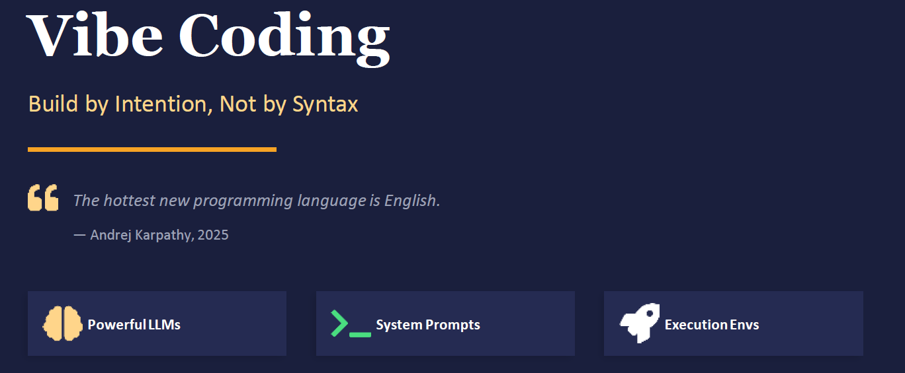
Vibe Coding is a new AI-assisted software development approach where developers describe their intent in plain English, and large language models generate and refine the code. Instead of focusing on syntax, you focus on outcomes — “build by intention, not by syntax.”.

🔑 Core Idea
- Traditional coding: You write exact instructions line by line.
- Vibe coding: You describe what you want (e.g., “Add a dark mode toggle that persists across sessions”), and the AI proposes code changes.
- Developer’s role: More like a director — reviewing, testing, and steering the AI output rather than hand-crafting every loop or function.
⚙️ How It Works
- Describe intent: Plain English prompt (e.g., “Build a dashboard showing monthly revenue by product line from Postgres”).
- AI generates code: Frontend, backend, database queries, integrations.
- Review & refine: You iterate conversationally (“Move the date filter to the top”).
- Deploy: Some platforms support “vibe deploying” — one-click deployment to production.

🔗 Feasibility for .NET Developers
As a .NET developer, vibe coding means:
- Using Copilot, Cursor, or Azure AI Studio to describe features in natural language.
- Letting AI generate ASP.NET Core controllers, EF Core queries, or Blazor components.
- Reviewing diffs, running tests, and refining via prompts.
- Example: Instead of writing LINQ manually, you might say: “Fetch all customers who purchased more than 5 items last month and display them in a Razor page table.” → AI generates the query and Razor markup, you validate and adjust.
⚠️ Risks & Trade-offs
1. Hallucinations (Verify correctness): ??
- Meaning: AI sometimes “makes things up” — inventing APIs, methods, or libraries that don’t exist.
- Example: You ask for “a .NET API to detect sarcasm in text.” The AI might generate a TextAnalysis.SarcasmDetector class, but no such library exists.
- Trade-off: Saves time when it’s correct, but you must validate against official docs.
- Mitigation in .NET: Always cross-check generated code with NuGet packages or Microsoft docs before integrating.
2. Over-Engineering
- Meaning: AI may produce unnecessarily complex solutions when a simpler one would do.
3. Ownership
- Meaning: Even if AI writes the code, you own it — you must understand, maintain, and debug it.
- Example: AI generates a LINQ query for customer segmentation. If requirements change, you’ll need to adjust it yourself.
- Trade-off: AI accelerates development, but doesn’t replace developer responsibility.
- Mitigation in .NET: Treat AI output like code from a junior developer — review, refactor, and add tests before production.

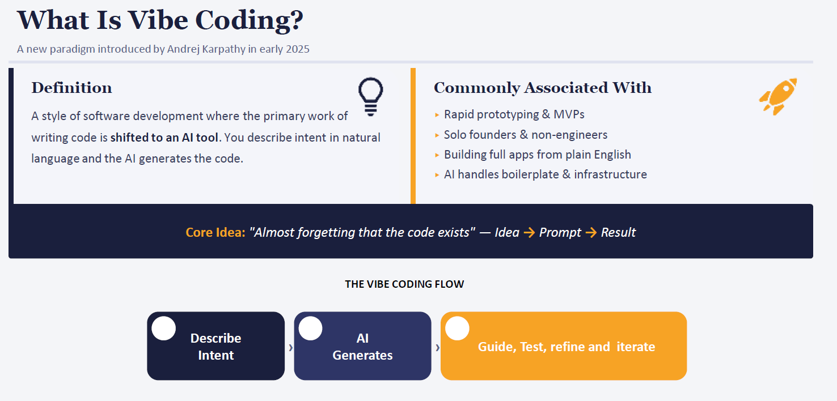
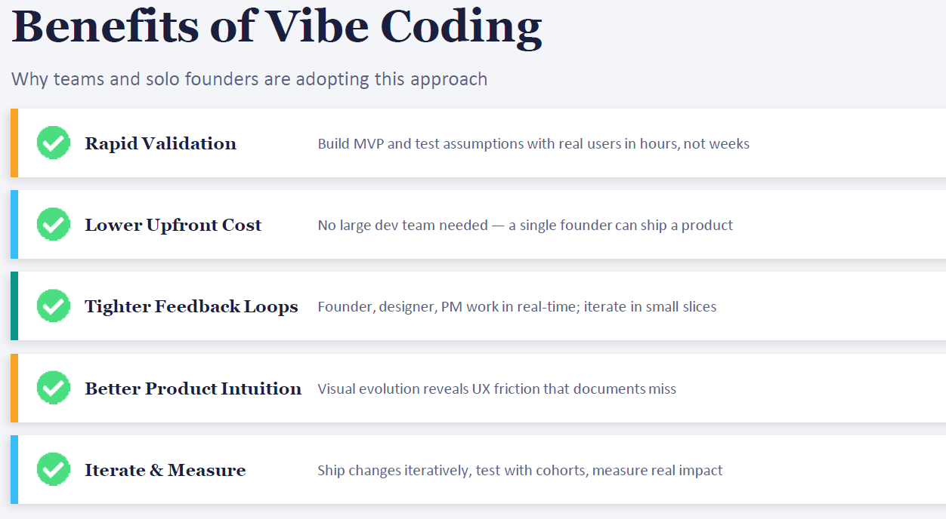
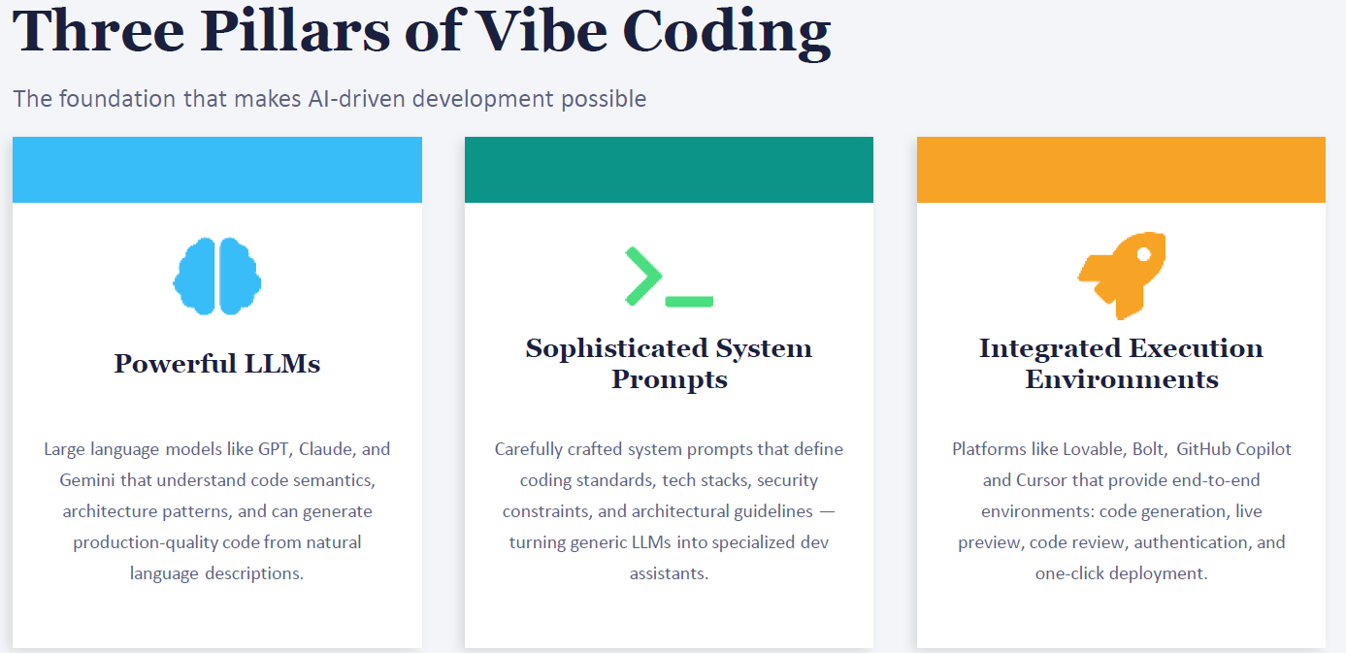
🧠 1. Powerful LLMs
- What it means: Large Language Models (LLMs) like GPT, Claude, or Gemini are the “brains” of vibe coding.
- Role: They understand code semantics, design patterns, and can generate production-quality code from plain English.
- .NET Feasibility:
  - You describe: “Create an ASP.NET Core API that logs user activity to SQL Server.”
  - The LLM generates controllers, EF Core models, and SQL queries.
- Key point: Instead of memorizing syntax, you focus on describing intent.
💻 2. Sophisticated System Prompts
- What it means: Prompts are not just casual instructions — they define coding standards, tech stacks, and constraints.
- Role: They turn a generic LLM into a specialized dev assistant.
- .NET Feasibility:
  - You set a system prompt: “Always use C#, ASP.NET Core 8, follow Clean Architecture, enforce JWT authentication.”
  - Now every AI-generated snippet respects those rules.
- Key point: Prompts act like architectural guardrails, ensuring consistency across your microservices.

🚀 3. Integrated Execution Environments
- What it means: Platforms like GitHub Copilot, Cursor, or Bolt give you a full workflow: not just code generation, but also previews, reviews, authentication, and deployment.
- Role: They handle code generation, live previews, reviews, authentication, and even one-click deployment.
- .NET Feasibility:
  - You use Copilot inside Visual Studio or Rider.
  - It generates code, runs tests, and integrates with Azure DevOps pipelines.
- Key point: You don’t just get code — you get a workflow from idea → code → deploy.

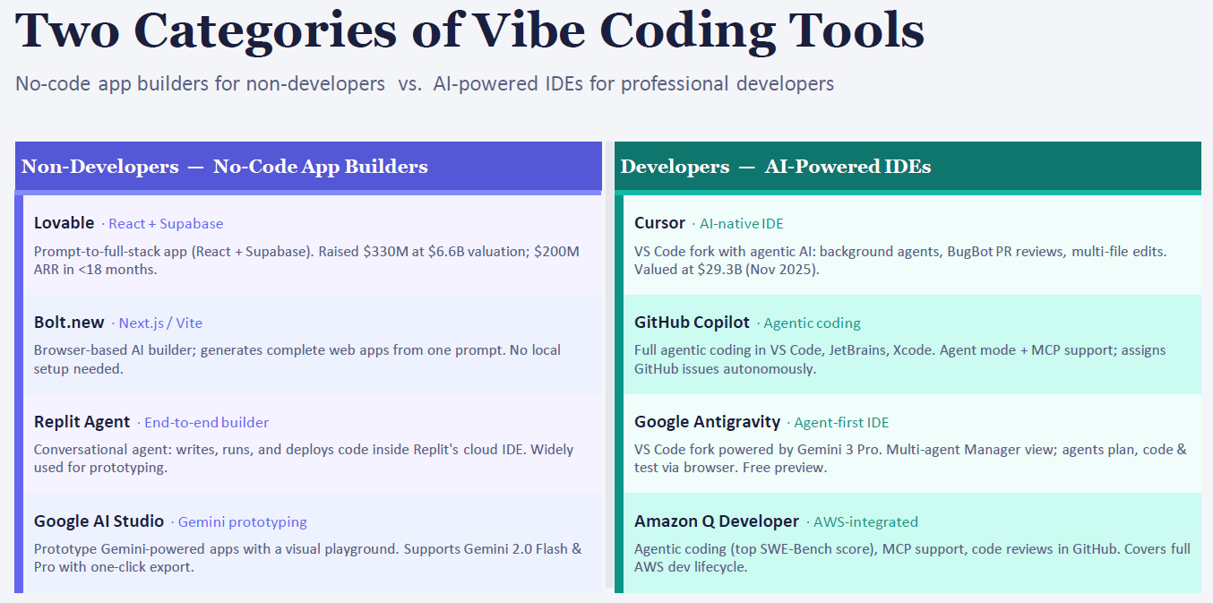

🟣 For Non-Developers — No-Code App Builders
These tools let people with little or no coding background build apps by describing them in plain language. They focus on speed and accessibility.
- Lovable (React + Supabase) → You type a prompt like “Build a task manager with login and notifications”. → It scaffolds a full React + Supabase app automatically. → Raised huge funding because non-developers can ship apps fast.
- Bolt.new (Next.js / Vite) → Browser-based builder. No local setup. → Generates complete web apps from one prompt. → Great for prototypes or quick demos.
- Replit Agent → Conversational agent inside Replit’s cloud IDE. → Writes, runs, and deploys code end-to-end. → Popular for prototyping and learning.
- Google AI Studio → Playground for Gemini models. → Lets you prototype AI-powered apps visually, then export with one click.
From above which are Browser-based builder??
Key point: These tools are about accessibility — enabling non-developers to build apps quickly without worrying about syntax.
🟢 For Developers — AI-Powered IDEs
These are aimed at professionals like you. They enhance your workflow by embedding AI into the IDE, respecting coding standards, and supporting complex projects.
- Cursor (AI-native IDE) → A VS Code fork with AI agents. → Can edit multiple files, review PRs, and fix bugs automatically. → Think of it as VS Code + AI copilots working in the background.
- GitHub Copilot → Integrated into VS Code, JetBrains, Xcode. → Agent mode can assign GitHub issues, generate code, and support MCP (Model Context Protocol). → Already widely used in enterprise .NET projects.
- Google Antigravity → Another VS Code fork, powered by Gemini. → Multi-agent view: agents plan, code, and test collaboratively. → Still in preview, but shows where IDEs are heading.
- Amazon Q Developer → AWS-integrated AI IDE. → Covers full AWS lifecycle: coding, reviewing, deploying. → Strong in cloud-native workflows.
From Above witch can Integrate with VS code, Visual studio??
Key point: These tools are about power and integration — giving professional developers AI agents inside their IDEs to accelerate serious projects.

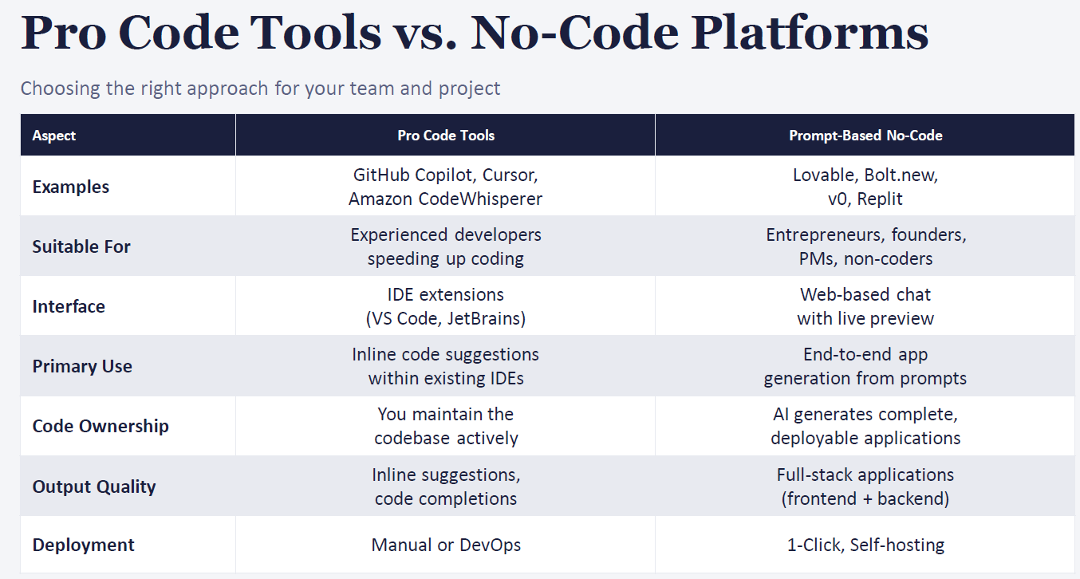
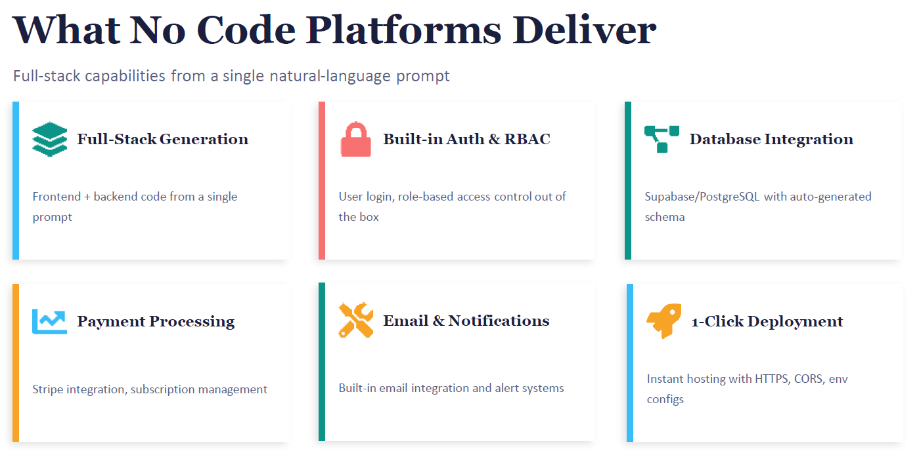
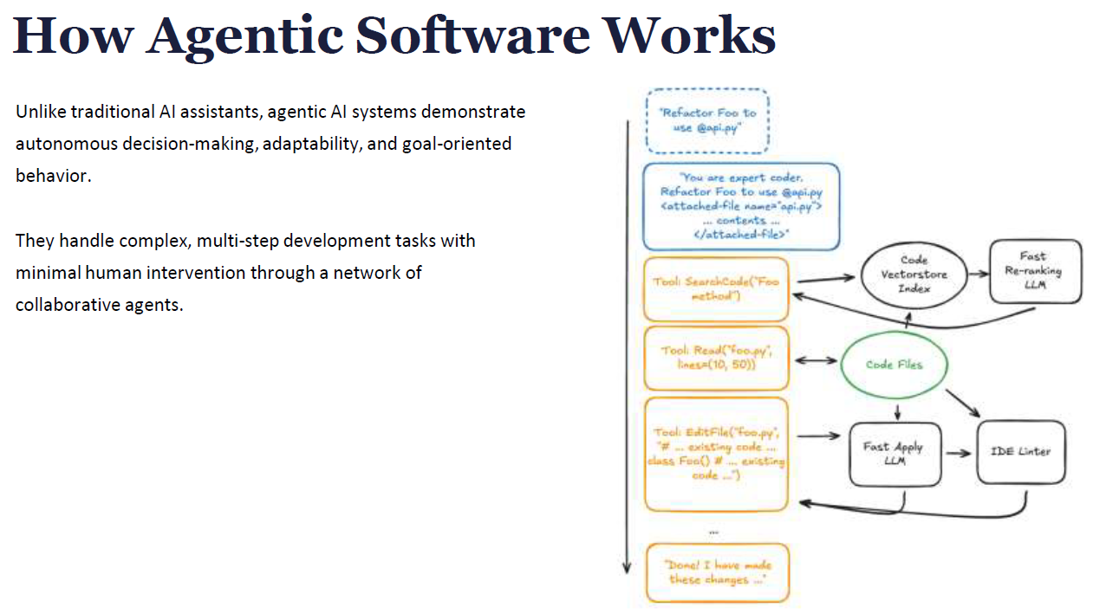

🔑 Core Idea
- Traditional AI assistants: They respond to prompts but wait for you to guide every step.
- Agentic AI systems: They act more like autonomous developers. They can plan, search, read, edit, and validate code with minimal human intervention.
- Think of them as a team of specialized agents working together toward a coding goal.

🧩 How It Works (Flow)
- You give a high-level goal Example: “Refactor Foo to use api.py” → Instead of just suggesting snippets, the agent plans the steps.
- Agents collaborate
  - Search agent: Finds where Foo is defined.
  - Read agent: Opens foo.py and locates relevant lines.
  - Edit agent: Modifies the file to import and use api.py.
  - Validation agent: Runs linter/tests to confirm correctness.
- Autonomous loop
  - The system doesn’t stop after one suggestion.
  - It iterates: searches, edits, checks, and reports back “Done! I have made these changes…”.
⚙️ Components in the Diagram
- Code Vectorstore Index → Keeps track of your codebase context.
- Fast Re-ranking LLM → Chooses the most relevant files/snippets.
- Code Files → The actual source code.
- Fast Apply LLM → Applies edits intelligently.
- IDE Linter → Validates changes before committing.

✅ Why It Matters for You (.NET Feasibility)
Imagine you’re maintaining a large ASP.NET Core microservice:
- You say: “Refactor all controllers to use a shared logging middleware.”
- An agentic system could:
  - Search all controllers.
  - Read their code.
  - Insert middleware references.
  - Run tests to confirm logging works.
  - Report back with a summary of changes.
This is beyond Copilot’s inline suggestions — it’s multi-step autonomous coding.
⚠️ Trade-off
- Pros: Huge productivity boost, handles repetitive refactors, enforces consistency.
- Cons: You must still review changes — autonomy can introduce errors or unintended side effects.

Best Practices for Vibe Coding
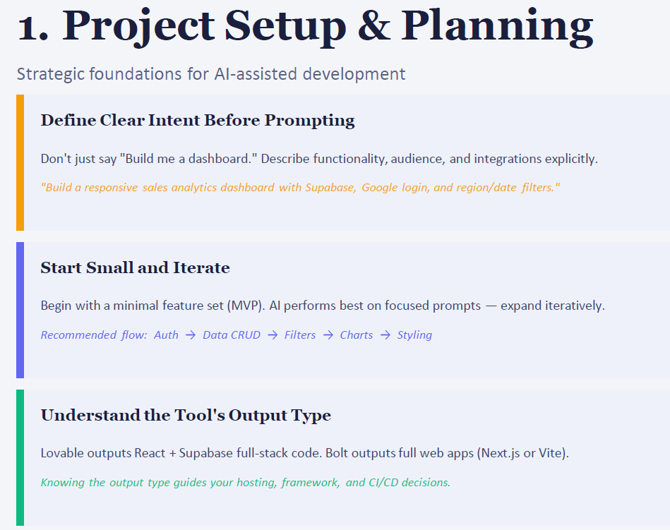
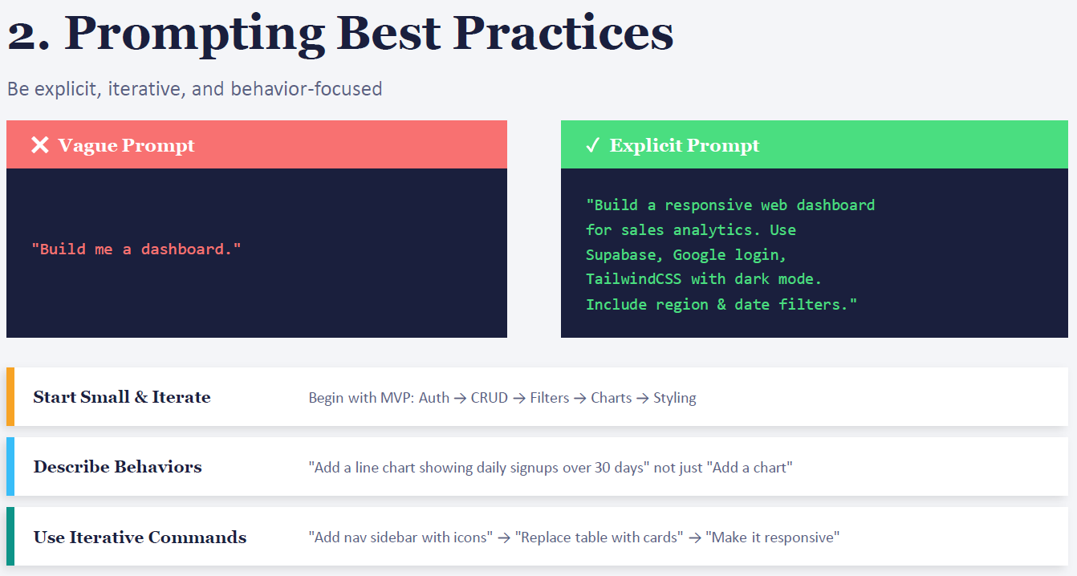
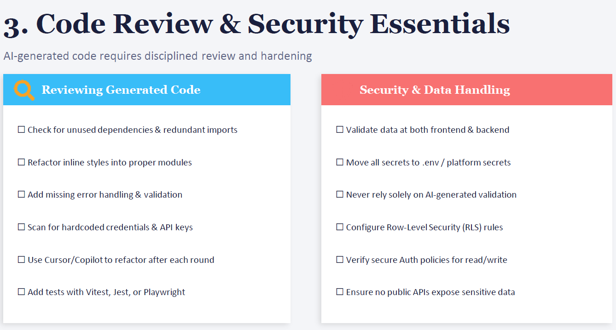
🔍 Reviewing Generated Code
When AI writes code, treat it like a junior developer’s draft — useful, but needs polish.
- Unused dependencies & redundant imports AI often adds extra using statements or packages. Clean them up to avoid bloat. Example: Copilot might add using System.Net.Http; even if you don’t use it.
- Refactor inline styles into proper modules In web projects, AI may embed CSS inline. Move styles into .css or .scss files for maintainability.
- Add missing error handling & validation AI code often skips edge cases. Example: A generated API might not check for null inputs. Add proper validation.
- Scan for hardcoded credentials & API keys Sometimes AI suggests string apiKey = "12345";. This is unsafe — move secrets to configuration.
- Iterative refactoring with Copilot/Cursor Use AI again to clean up after each round. Example: “Refactor this controller to follow Clean Architecture.”
- Add tests (Vitest, Jest, Playwright, xUnit for .NET) AI code without tests is risky. Generate unit/integration tests to validate behavior.
🔐 Security & Data Handling
AI won’t always enforce best practices — you must.
- Validate data at frontend & backend Don’t trust client-side validation alone. Always re-check on the server.
- Move secrets to .env or platform secrets Never leave keys in source code. Use Azure Key Vault or environment variables.
- Don’t rely solely on AI validation AI might generate a regex for email validation, but you need robust libraries and checks.
- Configure Row-Level Security (RLS) In databases (like Postgres/SQL Server), enforce that users only see their own rows.
- Verify secure Auth policies Ensure JWT tokens, OAuth flows, and role policies are correctly configured.
- Prevent public API exposure Double-check that sensitive endpoints aren’t left open without authentication.
✅ Why This Matters for You (.NET Example)
Imagine Copilot generates an ASP.NET Core API for customer data:
- It works, but has no null checks, hardcoded connection strings, and no authentication.
- If you deploy as-is, you risk data leaks.
- By applying these review & security essentials, you harden the code before production.

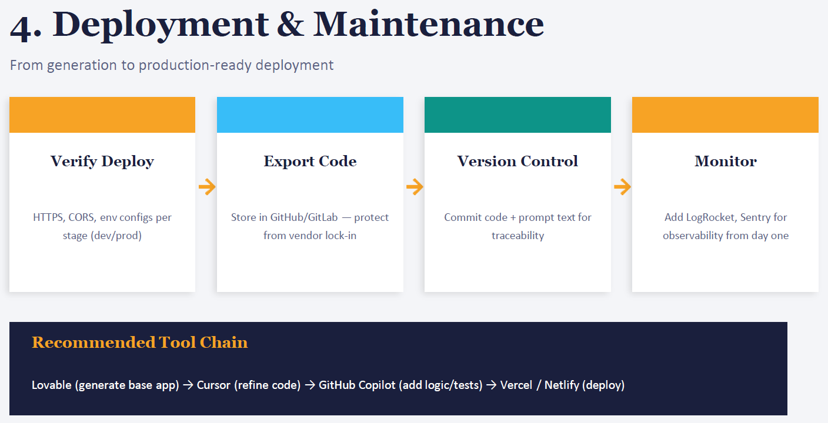
🔄 The Four Stages
- Verify Deploy
  - Before pushing live, check:
    - HTTPS → secure communication.
    - CORS → configure cross-origin rules correctly.
    - Environment configs → separate dev, staging, and production settings.
  - In .NET: use appsettings.Development.json vs appsettings.Production.json.
- Export Code
  - Don’t leave your code locked inside an AI platform.
  - Export to GitHub/GitLab so you own the repo.
  - This avoids vendor lock-in and gives you full control.
  - In .NET: push generated ASP.NET Core projects to GitHub, then integrate with Azure DevOps pipelines.
- Version Control
  - Commit both code and prompt text.
  - Why? Traceability — you’ll know not just what changed, but which AI prompt created it.
  - Example: Commit message →
Code
feat: Added JWT auth (Prompt: "Create ASP.NET Core API with JWT")
- Monitor
  - Add observability tools from day one.
  - Examples:
    - LogRocket → frontend session replay.
    - Sentry → error tracking.
  - In .NET: use Serilog or Application Insights for logging and telemetry.
🛠 Recommended Tool Chain (general flow)
- Lovable → generate base app quickly.
- Cursor → refine and restructure code.
- GitHub Copilot → add business logic, tests, pipelines.
- Vercel / Netlify → deploy with one click.
- For .NET, swap Vercel/Netlify with Azure App Service or Azure Kubernetes Service.
✅ Why It Matters for You
As a .NET developer:
- You’ll use Copilot inside Visual Studio to generate code.
- Export to GitHub for version control.
- Configure Azure DevOps pipelines for deployment.
- Add monitoring with Application Insights or Sentry.
This ensures your AI-generated code is secure, traceable, and maintainable in production.

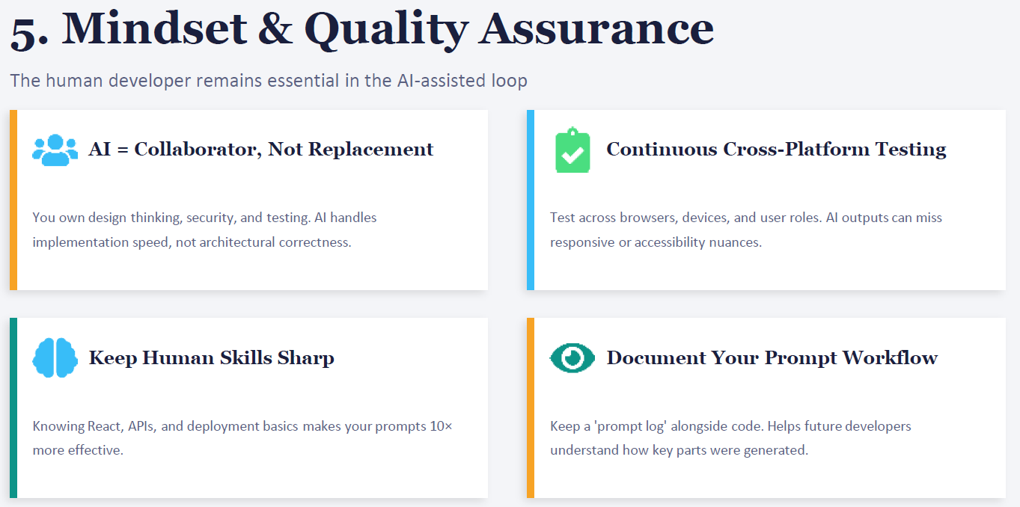
🧑‍🤝‍🧑 1. AI = Collaborator, Not Replacement
- AI accelerates implementation, but you own design thinking, security, and testing.
- Example in .NET: Copilot can scaffold an ASP.NET Core API, but you decide the architecture (Clean Architecture, DDD, etc.) and enforce security policies.
🧪 2. Continuous Cross-Platform Testing
- AI outputs may miss responsive design or accessibility details.
- You must test across browsers, devices, and user roles.
- Example: An AI-generated Blazor component might look fine on desktop but break on mobile. You catch this in QA.
📚 3. Keep Human Skills Sharp
- Knowing frameworks (React, ASP.NET Core, EF Core, APIs) makes your prompts 10x more effective.
- Example: If you understand JWT authentication, you can prompt Copilot precisely: “Generate middleware for JWT validation with role-based claims.”
- Without that knowledge, prompts stay vague and outputs weaker.
📝 4. Document Your Prompt Workflow
- Keep a prompt log alongside code.
- This helps future developers understand how key parts were generated.
- Example: Commit message:
Code
feat: Added Kafka consumer (Prompt: "Generate MassTransit Kafka Rider consumer for audit trail")
✅ Why It Matters
For you as a .NET developer:
- AI is your accelerator, not your architect.
- You must still test, secure, and document.
- Your human expertise ensures AI output is production-ready.

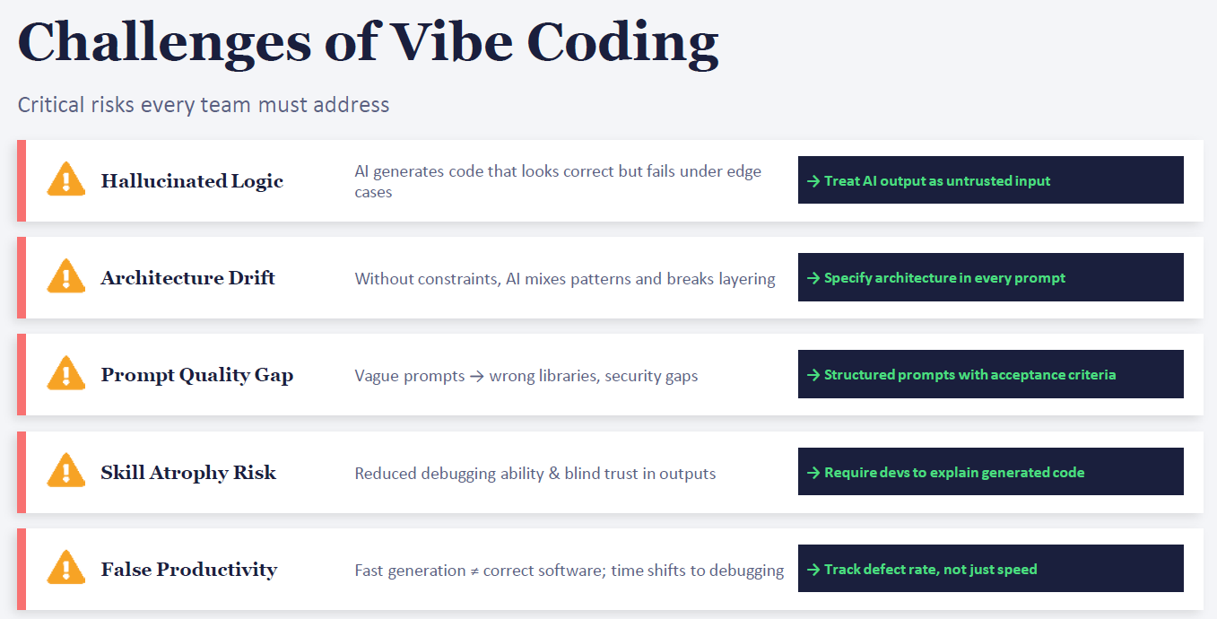
⚠️ 1. Hallucinated Logic
- Problem: AI generates code that looks correct but fails under edge cases.
- Example in .NET: Copilot suggests a LINQ query that works for small datasets but throws exceptions with null values.
- Mitigation: Treat AI output as untrusted input. Always add manual tests and code reviews.
⚠️ 2. Architecture Drift
- Problem: Without constraints, AI mixes patterns (e.g., MVC + Clean Architecture) and breaks layering.
- Example in .NET: AI scaffolds controllers that directly access EF Core DbContext, bypassing your repository layer.
- Mitigation: Specify architecture in every prompt: “Generate ASP.NET Core API using Clean Architecture with repository pattern.”
⚠️ 3. Prompt Quality Gap
- Problem: Vague prompts lead to wrong libraries or insecure defaults.
- Example in .NET: Prompting “Add authentication” → AI picks cookie auth instead of JWT/OAuth.
- Mitigation: Use structured prompts with acceptance criteria: “Add JWT authentication with role-based claims, no hardcoded secrets, and unit tests.”
⚠️ 4. Skill Atrophy Risk
- Problem: Developers may lose debugging ability if they blindly trust AI outputs.
- Example in .NET: AI generates Kafka consumer logic, but you don’t understand retry policies.
- Mitigation: Require developers to explain generated code in reviews — keeps skills sharp.
⚠️ 5. False Productivity
- Problem: Fast generation ≠ correct software. Time shifts to debugging.
- Example in .NET: AI generates a microservice quickly, but you spend days fixing bugs in production.
- Mitigation: Track defect rate, not just speed. Measure quality outcomes.
✅ Why This Matters for You
As a .NET developer working with microservices and Kafka:
- AI can accelerate scaffolding, but you must enforce architecture discipline.
- Write structured prompts to avoid insecure defaults.
- Keep your debugging and architectural skills sharp by reviewing AI output critically.
- Measure productivity by quality metrics (tests passed, defects reduced), not just lines of code generated.

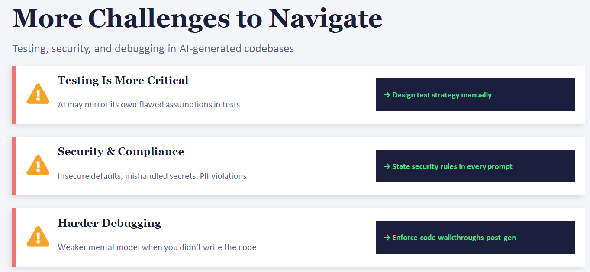
🧪 1. Testing Is More Critical
- Problem: AI can generate tests that simply mirror its own assumptions. If the code is flawed, the tests may also be flawed.
- Action: You must design a manual test strategy.
- .NET Example: Copilot might generate unit tests for a controller but skip edge cases (null inputs, invalid tokens). You need to add xUnit/NUnit tests that deliberately break the API to confirm resilience.
🔐 2. Security & Compliance
- Problem: AI often defaults to insecure practices — hardcoded secrets, weak validation, or exposing sensitive data.
- Action: Explicitly state security rules in every prompt.
- .NET Example: When prompting Copilot, include: “Generate ASP.NET Core API with JWT authentication, role-based authorization, and no hardcoded secrets.”
- This ensures the AI respects your compliance needs (GDPR, HIPAA, etc.).
🐞 3. Harder Debugging
- Problem: Debugging is tougher because you didn’t write the code — your mental model of the logic is weaker.
- Action: Enforce code walkthroughs post-generation.
- .NET Example: After Copilot generates a Kafka consumer, walk through the code line by line, add logging, and ensure retry logic works as expected. Treat it like reviewing a junior developer’s PR.
✅ Why This Matters
For you as a .NET developer:
- Testing → Build robust test suites (xUnit, MSTest, integration tests).
- Security → Use Azure Key Vault, environment configs, and strict auth policies.
- Debugging → Always review AI-generated code with your team before merging.

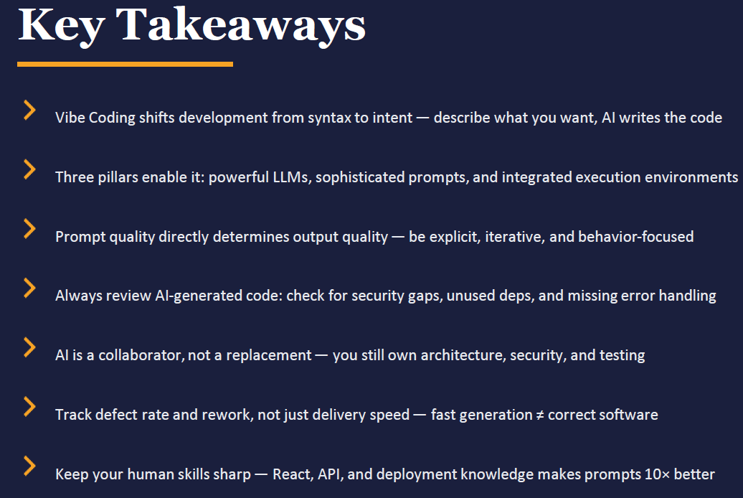
🌟 Key Takeaways
- Shift from Syntax → Intent
  - You don’t have to remember every API call or syntax detail.
  - Instead, you describe what you want, and AI scaffolds the code.
  - Example: “Create an ASP.NET Core API with JWT authentication and role-based claims.”
- Three Pillars Enable It
  - LLMs (brains) → understand context and generate code.
  - Prompts (guardrails) → enforce architecture, security, and standards.
  - Execution Environments (workflow) → integrate generation, testing, and deployment.
- Prompt Quality = Output Quality
  - Vague prompt → wrong libraries, insecure defaults.
  - Structured prompt → correct architecture, secure code, tests included.
  - Example: “Generate Kafka consumer using MassTransit Rider, with retry policy and unit tests.”
- Always Review AI-Generated Code
  - Check for:
    - Security gaps
    - Unused dependencies
    - Missing error handling
  - Treat AI output like a junior developer’s draft — useful, but needs polish.
- AI = Collaborator, Not Replacement
  - You still own architecture, security, and testing.
  - AI accelerates implementation, but doesn’t guarantee correctness.
- Measure Quality, Not Just Speed
  - Fast generation ≠ correct software.
  - Track defect rate, rework, and test coverage.
  - Productivity is about fewer bugs, not just more lines of code.
- Keep Human Skills Sharp
  - Knowing frameworks (ASP.NET Core, EF Core, Kafka, APIs) makes your prompts 10× better.
  - The sharper your skills, the more precise your AI collaboration.

Module 2: GitHub Copilot Introduction
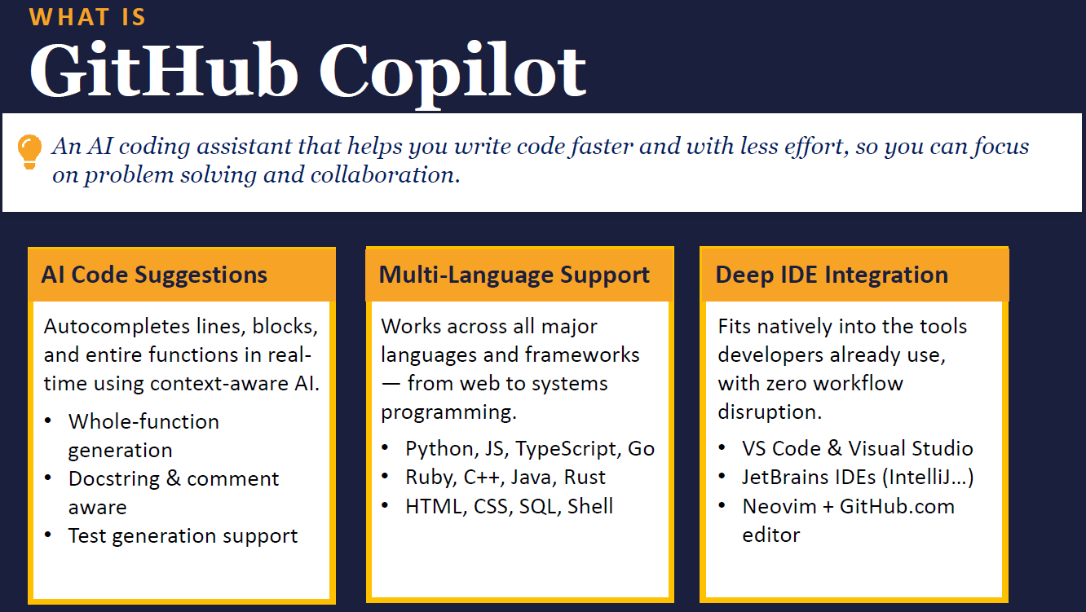
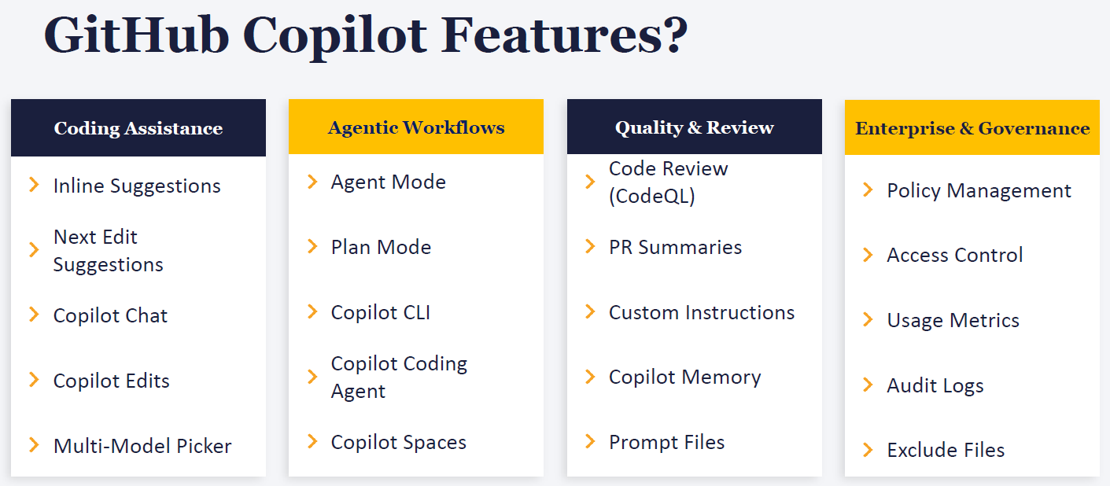
🧑‍💻 1. Coding Assistance
These are the everyday features you see inside Visual Studio, Rider, or VS Code.
- Inline Suggestions → Ghost text that appears as you type, ready to accept with Tab.
- Next Edit Suggestions → Copilot predicts your next likely change.
- Copilot Chat → Ask questions directly in the IDE (“Explain this method”).
- Copilot Edits → AI can refactor or rewrite sections of code.
- Multi-Model Picker → Choose between different AI models for suggestions.
🤖 2. Agentic Workflows
This is where Copilot moves beyond autocomplete into multi-step automation.
- Agent Mode → Copilot acts like an autonomous agent, planning tasks.
- Plan Mode → It outlines steps before coding (like a mini design doc).
- Copilot CLI → AI assistance directly in your terminal.
- Copilot Coding Agent → Handles multi-file edits, bug fixes, and PR reviews.
- Copilot Spaces → Collaborative AI workspaces for teams.??
Which mode is by default enable in Visual studio ??
🛡️ 3. Quality & Review
Copilot helps enforce standards and improve reliability.
- Code Review (CodeQL) → Automated security scanning.
- PR Summaries → Generates summaries of pull requests.??
- Custom Instructions → Tailor Copilot to your coding style.??
- Copilot Memory → Remembers context across sessions.??
- Prompt Files → Store reusable prompts alongside code.
🏢 4. Enterprise & Governance
For organizations, Copilot includes compliance and control features.
- Policy Management → Define rules for how Copilot is used.
- Access Control → Manage who can use Copilot.
- Usage Metrics → Track adoption and productivity.
- Audit Logs → Record Copilot activity for compliance.
- Exclude Files → Prevent Copilot from touching sensitive files.
✅ Why This Matters for You
As a .NET developer working with microservices:
- Coding Assistance → Inline suggestions speed up scaffolding controllers, EF Core queries, Kafka consumers.
- Agentic Workflows → Copilot can plan and refactor across multiple services.
- Quality & Review → Automated PR summaries and CodeQL scans help secure your microservices.
- Enterprise & Governance → Useful if you’re deploying Copilot across a team with Azure DevOps.

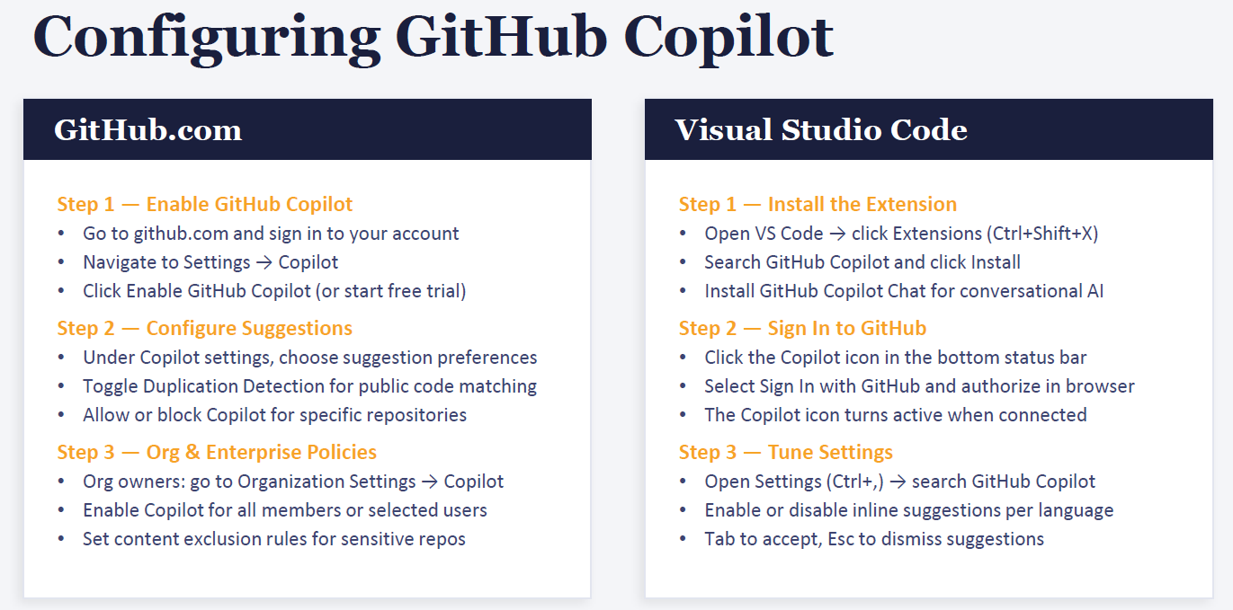
Write down all steps??
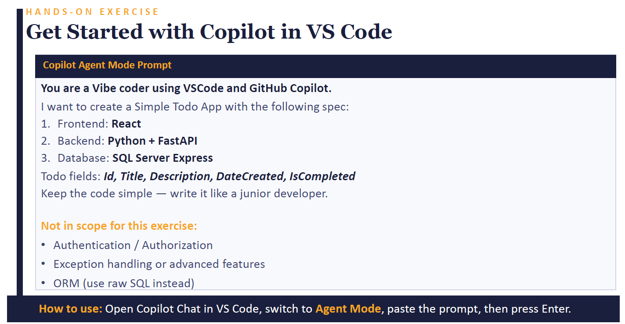
What are different modes (like planning, agentic mode) and there use and best practices ??

🧩 Key Modes in Copilot
1. Agentic Mode
- What it does: Copilot acts like an autonomous agent. Instead of just suggesting snippets, it can plan, search across files, edit multiple files, and even open PRs.
- Use case: Large refactors, bug fixes, or multi-file changes.
- Best practice:
  - Treat it like a junior developer working independently.
  - Always review its PRs before merging.
  - Use it for repetitive tasks (e.g., adding logging middleware across all controllers).
2. Plan Mode
- What it does: Copilot outlines steps before coding — like a mini design doc.
- Use case: When you want clarity before implementation.
- Best practice:
  - Use Plan Mode to validate architecture decisions.
  - Example: “Plan how to add JWT authentication to my ASP.NET Core API.”
  - Compare its plan against your standards (Clean Architecture, DDD).
3. Copilot CLI
- What it does: AI assistance directly in your terminal.
- Use case: Running commands, scaffolding projects, or generating scripts.
- Best practice:
  - Use for DevOps tasks (YAML pipelines, Dockerfiles).
  - Always run commands in a safe environment first.
4. Copilot Coding Agent
- What it does: Handles multi-file edits, bug fixes, and PR reviews.
- Use case: Complex changes across services.
- Best practice:
  - Use for cross-cutting concerns (e.g., adding retry logic to all Kafka consumers).
  - Pair it with manual code walkthroughs to avoid hidden issues.
5. Copilot Spaces
- What it does: Collaborative AI workspaces for teams.
- Use case: Shared environments where multiple developers interact with AI.
- Best practice:
  - Use for brainstorming or prototyping.
  - Document prompts so teammates understand how code was generated.
✅ Best Practices Across Modes
- Always review AI output → Treat it as a draft, not final code.
- Be explicit in prompts → Include architecture, security, and testing requirements.
- Document prompt workflows → Keep a “prompt log” alongside commits.
- Measure quality, not speed → Track defect rate and rework.
- Keep skills sharp → The better you know .NET, Kafka, and DevOps, the stronger your prompts.

Copilot Architecture

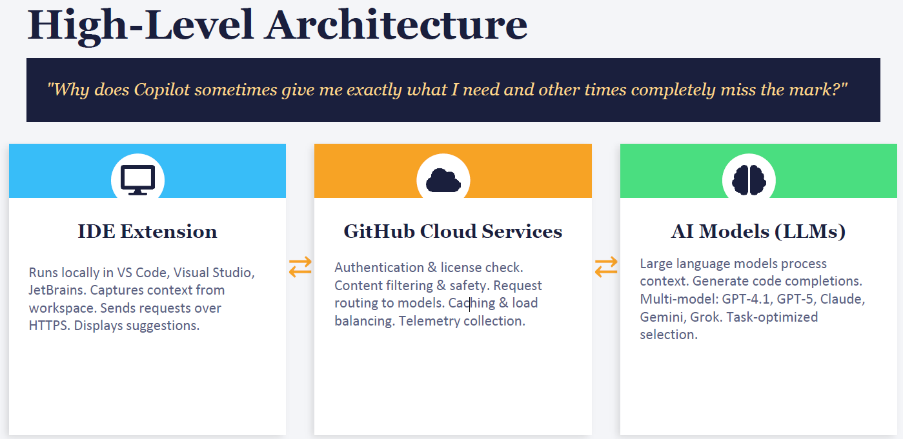
🖥️ 1. IDE Extension (Blue Section)
- Runs locally inside VS Code, Visual Studio, JetBrains.
- Captures context from your workspace: open files, recent edits, comments.
- Sends requests securely over HTTPS.
- Displays suggestions inline (ghost text, chat, or edits). 👉 If your workspace context is limited (e.g., only one file open), Copilot may miss broader architectural intent.
☁️ 2. GitHub Cloud Services (Orange Section)
🔐 Authentication & License Checks
- Meaning: Ensures you’re a valid Copilot user with the right subscription.
- Example: You open Visual Studio with Copilot → GitHub Cloud verifies your GitHub account and enterprise license before allowing suggestions.
- Why it matters: Prevents unauthorized use and enforces company policies.
🛡️ Content Filtering & Safety Rules
- Meaning: Blocks unsafe or sensitive outputs.
- Example: If you type “Generate code to bypass login security”, Copilot won’t return results.
- Why it matters: Keeps generated code aligned with compliance and security standards.
🔀 Request Routing to the Right AI Model
- Meaning: Chooses the best model (GPT-4.1, GPT-5, Claude, Gemini, etc.) depending on your task.
- Example:
  - For a short inline completion (like a LINQ query), a faster lightweight model is used.
  - For a complex refactor across multiple files, a larger reasoning model is selected.
- Why it matters: Balances speed vs. accuracy.
⚡ Caching & Load Balancing
- Meaning: Stores common requests and spreads traffic across servers.
- Example: Thousands of developers ask Copilot to scaffold an ASP.NET Core API → GitHub Cloud caches common completions so responses are faster.
- Why it matters: Ensures performance and reliability even under heavy load.
📊 Telemetry Collection
- Meaning: Collects anonymous usage data to improve future suggestions.
- Example: GitHub Cloud notices many developers request “JWT authentication” scaffolds → future models are tuned to generate better JWT code.
- Why it matters: Helps Copilot evolve based on real developer needs.

🧠 3. AI Models (Green Section)
- Large Language Models (LLMs) like GPT-4.1, GPT-5, Claude, Gemini, Grok.
- Process the context and generate code completions.
- Multi-model selection: Copilot chooses the model best suited for the task. 👉 If the wrong model is picked or context is incomplete, output may feel “off.”
🔄 Why Results Vary
- Good matches happen when:
  - IDE context is rich (comments, multiple files open).
  - Prompts are explicit (architecture, security, testing included).
  - The right model is selected for the task.
- Misses happen when:
  - Context is too vague or incomplete.
  - Prompts are underspecified.
  - The model defaults to generic patterns.
✅ Best Practice for You
As a .NET developer:
- Keep multiple relevant files open (controllers, services, configs) so Copilot sees context.
- Use structured prompts: “Generate ASP.NET Core API with Clean Architecture, JWT auth, and unit tests.”
- Treat Copilot’s output as a draft, then refine with your architectural standards.

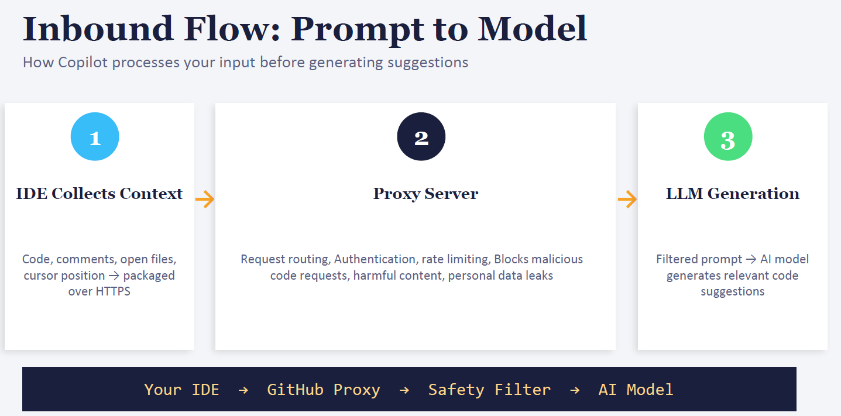
🔄 Step-by-Step Flow
1. Your IDE
- What happens:
  - Copilot runs inside your IDE (VS Code, Visual Studio, JetBrains).
  - It collects context: open files, cursor position, comments, and surrounding code.
  - Packages this context securely over HTTPS.
- Example: You’re editing OrderController.cs in ASP.NET Core. Copilot sees:
  - The OrderController class.
  - Your comment: // TODO: Add JWT validation.
  - Cursor inside the PostOrder method. → This context is sent to GitHub Cloud.
2. GitHub Proxy??
- What happens:
  - Routes the request to the right AI model.
  - Checks authentication (valid Copilot license).
  - Applies rate limiting (so one user doesn’t overload servers).
  - Blocks malicious requests (e.g., “generate malware”).
- Example: You type: “Generate Kafka consumer with retry logic.”
  - Proxy ensures you’re authenticated.
  - Routes to a reasoning model (since it’s multi-file logic).
  - Filters out unsafe instructions if you accidentally include sensitive data.
3. Safety Filter
- What happens:
  - Removes harmful or sensitive content before sending to the AI model.
  - Prevents secrets, personal data, or unsafe code from leaking.
- Example: If your prompt includes connectionString = "password123", the filter strips it out before sending to the model. → Copilot then suggests using appsettings.json or environment variables instead.
4. AI Model
- What happens:
  - The filtered prompt reaches the chosen LLM (GPT-4.1, GPT-5, Claude, Gemini, etc.).
  - Model generates code suggestions based on context.
- Example: For your Kafka consumer prompt, the model might generate:
csharp
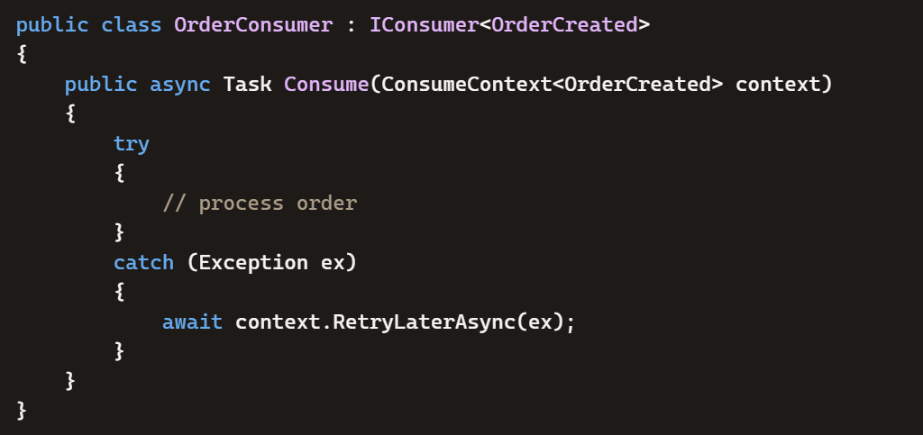→ You get inline suggestions in your IDE.
⚠️ Why Sometimes It Misses
- If context is trimmed (e.g., sensitive files filtered out), Copilot may only see part of your project.
- If routing picks a fast model for speed, you may get generic suggestions instead of deep reasoning.
- If your prompt is vague, Copilot fills gaps with assumptions, which may not match your architecture.
✅ Summary for You (.NET context)
- IDE → collects your code context.
- Proxy → authenticates, routes, and blocks unsafe requests.??
- Safety Filter → strips secrets or harmful content.
- AI Model → generates suggestions based on what remains.

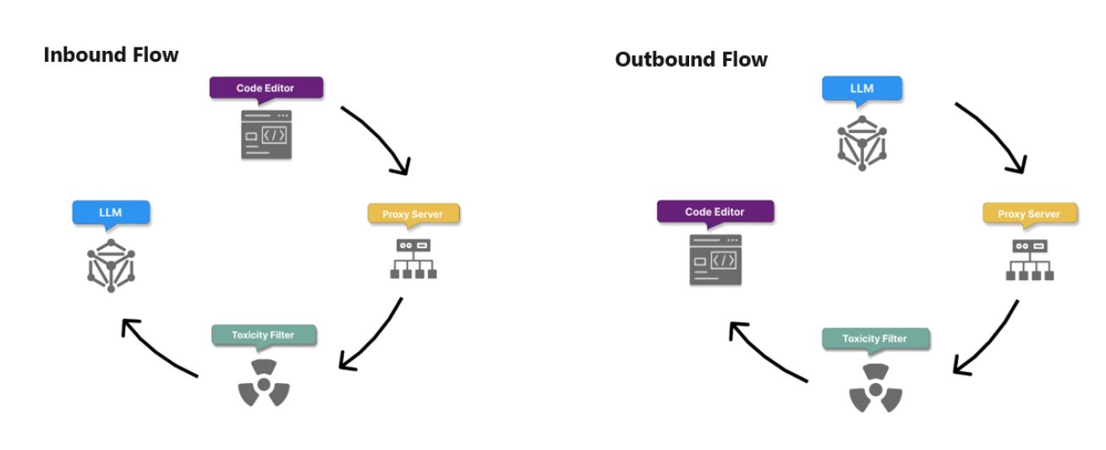
🔄 Inbound Flow (Prompt → Model)
This is the path when you send a request into Copilot.
- Code Editor (IDE)
  - Collects context: open files, cursor position, comments, surrounding code.
  - Example: You’re editing OrderController.cs and type // TODO: Add JWT validation.
- Proxy Server
  - Routes the request, checks authentication, applies rate limits.
  - Example: GitHub Cloud verifies your Copilot license and decides which AI model to use.
- Toxicity/Safety Filter
  - Removes harmful or sensitive content (like secrets or unsafe instructions).
  - Example: If your code includes connectionString = "password123", the filter strips it before sending.
- LLM (AI Model)
  - Processes the filtered prompt and generates code suggestions.
  - Example: Suggests middleware for JWT validation in ASP.NET Core.
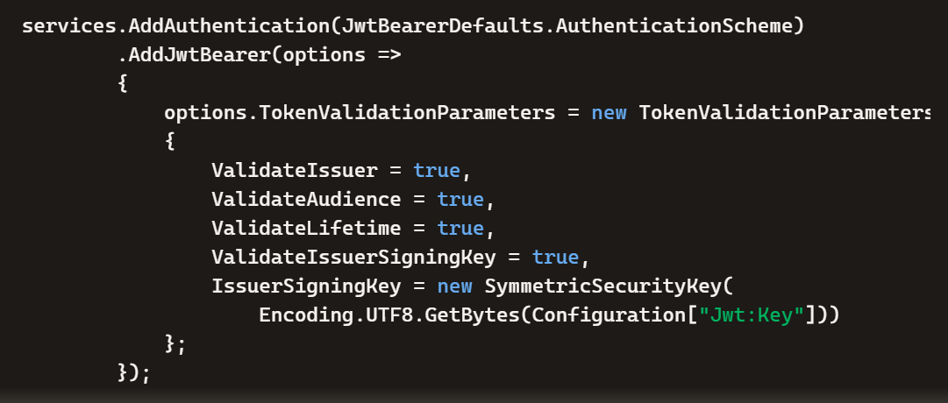
👉 Inbound = your intent flows into the model.
🔄 Outbound Flow (Model → You)
This is the path when the AI sends a suggestion back to your IDE.
- LLM (AI Model)
  - Generates code completion or refactor suggestion.
  - Example: Produces a Kafka consumer with retry logic.
- Proxy Server
  - Routes the response back, applies caching/load balancing.
  - Example: Ensures the suggestion is delivered quickly and securely.
- Toxicity/Safety Filter
  - Double-checks the output for unsafe or harmful code before it reaches you.
  - Example: Blocks if the AI accidentally suggests hardcoded credentials.
- Code Editor (IDE)
  - Displays the suggestion inline (ghost text, Copilot Chat, or edits).
  - Example: You see the Kafka consumer code appear in your editor, ready to accept or refine.
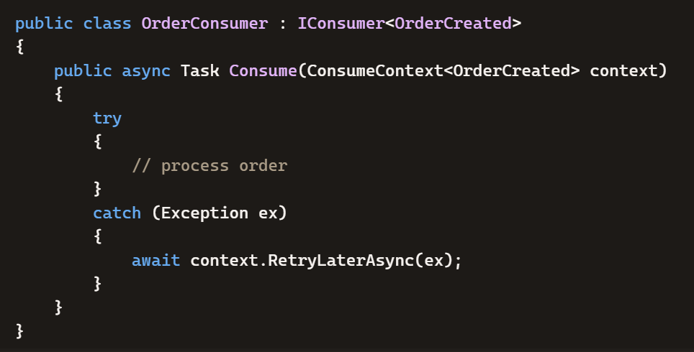
👉 Outbound = the model’s suggestion flows back to you.
✅ Why This Matters
- Inbound flow ensures your prompts are safe and properly routed.
- Outbound flow ensures AI suggestions are filtered and secure before reaching your IDE.
- Together, they form a closed loop of trust: your intent goes in, safe code comes out.

Proxy Server??
🔎 What the Proxy Server Does
- Authentication & License Validation
  - Confirms you’re a valid Copilot user with the right subscription.
  - .NET Example: You open Visual Studio with Copilot. The proxy checks your GitHub account and enterprise license before allowing suggestions for your ASP.NET Core project.
- Request Routing
  - Decides which AI model should handle your request (fast vs reasoning model).
  - .NET Example:
    - You type a simple LINQ query → proxy routes to a lightweight model for speed.
    - You ask Copilot to refactor a Kafka consumer across multiple files → proxy routes to a larger reasoning model for accuracy.
- Rate Limiting & Load Balancing
  - Prevents overload by limiting how many requests a single user can send per second.
  - Distributes traffic across servers to keep responses fast.
  - .NET Example: If you’re rapidly prompting Copilot while editing multiple microservices, the proxy smooths requests so you don’t overwhelm the system.
- Security Filtering (Pre-Check)
  - Blocks malicious or unsafe requests before they reach the AI model.
  - .NET Example: If you accidentally paste a database password in your prompt, the proxy strips it out before forwarding.
- Performance Optimization (Caching)
  - Stores common requests so repeated queries don’t always hit the model.
  - .NET Example: Thousands of developers ask Copilot to scaffold an ASP.NET Core API with JWT authentication. The proxy caches common completions so your request is answered faster.
⚠️ Why the Proxy Matters
- It protects you (no secrets or unsafe code leaks).
- It optimizes performance (fast responses even under heavy load).
- It routes intelligently (chooses the right AI model for your task).
- It enforces compliance (ensures enterprise rules are followed).
✅ Summary for You (.NET context) When you type a prompt in Visual Studio:
- The Proxy Server checks your license, filters unsafe input, decides which AI model to use, balances traffic, and caches common completions.
- That’s why sometimes you get lightning-fast suggestions (cached or lightweight model), and other times Copilot takes longer (reasoning model for complex refactors).

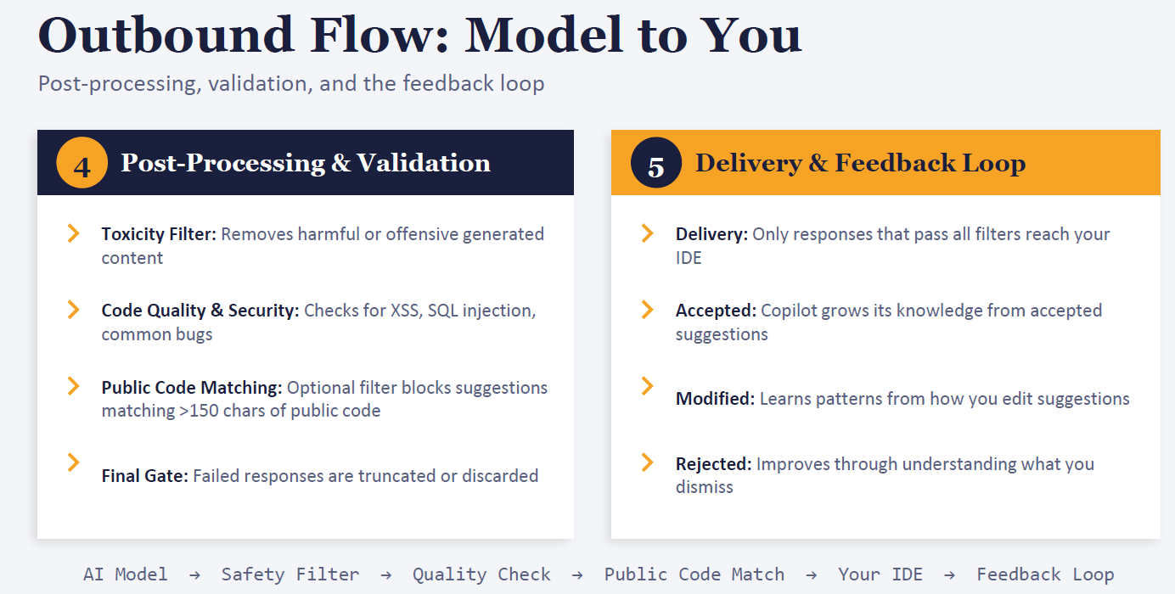
🔄 Step 1: Post-Processing & Validation
🛡️ Toxicity Filter
- What it does: Removes harmful or offensive generated content.
- .NET Example: If Copilot accidentally suggests logging sensitive user passwords, the filter blocks that output before it reaches you.
🔐 Code Quality & Security Checks
- What it does: Scans suggestions for common vulnerabilities (XSS, SQL injection, insecure defaults).
- .NET Example:
  - You ask Copilot to generate a login form.
  - If the AI suggests concatenating SQL strings like:
csharp
var query = "SELECT * FROM Users WHERE Name='" + username + "'";
→ The filter flags this as SQL injection risk and replaces it with parameterized queries using SqlCommand.
📚 Public Code Matching
- What it does: Optionally blocks suggestions that match large chunks of public code (>150 chars).
- .NET Example: If Copilot tries to paste a big section of open-source ASP.NET Identity code verbatim, the filter may truncate it to avoid licensing issues.
🚦 Final Gate
- What it does: If a suggestion fails checks, it’s truncated or discarded.
- .NET Example: If Copilot generates unsafe Kafka consumer logic (like swallowing all exceptions silently), the final gate may discard it rather than show you bad code.
🔄 Step 2: Delivery & Feedback Loop
📤 Delivery
- What it does: Only safe, validated suggestions reach your IDE.
- .NET Example: You see a secure JWT middleware snippet appear inline in Visual Studio.
✅ Accepted
- What it does: If you accept the suggestion, Copilot learns that this pattern is useful.
- .NET Example: You accept Copilot’s generated retry logic for MassTransit Kafka consumers → Copilot reinforces that retry policies are valuable in your context.
✏️ Modified
- What it does: If you edit the suggestion, Copilot learns from your changes.
- .NET Example: Copilot generates a LINQ query, but you change it to use AsNoTracking() for EF Core performance. Copilot learns that you prefer optimized queries.
❌ Rejected
- What it does: If you dismiss the suggestion, Copilot learns it wasn’t helpful.
- .NET Example: Copilot suggests cookie authentication, but you reject it because you use JWT. Copilot adapts to avoid cookie auth in future prompts.
⚠️ Why This Matters
- Outbound flow ensures you only see safe, secure, and relevant code.
- Your feedback loop (accept, modify, reject) actively trains Copilot to align with your coding style and architecture.
- Over time, Copilot becomes more tailored to your .NET + Kafka microservice stack.

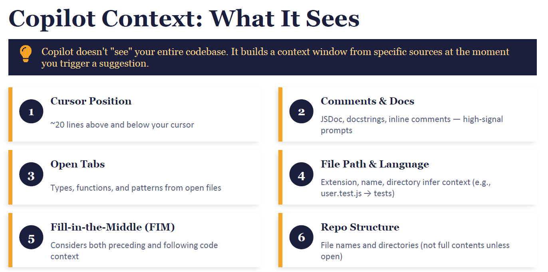
🔎 Six Sources of Context
1. Cursor Position (~20 lines above and below)
- Copilot looks at the code immediately around your cursor.
- .NET Example: If your cursor is inside OrderController.PostOrder(), Copilot sees the method body plus ~20 lines above and below. It won’t see unrelated files unless they’re open.
2. Comments & Docs
- Inline comments, XML docs, or JSDoc are high-signal prompts.
- .NET Example:
csharp
// TODO: Add JWT validation
Copilot uses this comment as a strong hint to generate authentication middleware.
3. Open Tabs
- Copilot reads types, functions, and patterns from files you have open.
- .NET Example: If you have OrderService.cs and OrderController.cs open, Copilot can connect them. If PaymentService.cs is closed, it won’t be considered.
4. File Path & Language
- File names, extensions, and directories give Copilot clues.
- .NET Example:
  - OrderController.cs → Copilot knows it’s a controller.
  - OrderTests.cs → Copilot infers it’s a test file and suggests unit test patterns.
5. Fill-in-the-Middle (FIM)
- Copilot considers both preceding and following code around a gap.
- .NET Example: If you leave a blank inside a method, Copilot looks at the code before and after to fill the missing logic.
6. Repo Structure
- Copilot sees file names and directories, not full contents unless opened.
- .NET Example: If your repo has /Consumers/OrderConsumer.cs, Copilot infers Kafka consumer patterns but won’t read the file unless it’s open.
⚠️ Key Insight
👉 Copilot doesn’t “see everything.” It builds a snapshot context from cursor, comments, open tabs, file paths, and repo structure.
- If you want better suggestions, open related files and add clear comments.
- Example: Writing // Consumer should retry on failure in OrderConsumer.cs gives Copilot a strong signal to generate retry logic.
✅ Summary for You (.NET context)
- Cursor → local method context.
- Comments → strong hints for intent.
- Open tabs → cross-file awareness.
- File path → role inference (controller, test, consumer).
- FIM → fills gaps in code.
- Repo structure → directory clues, not full codebase.
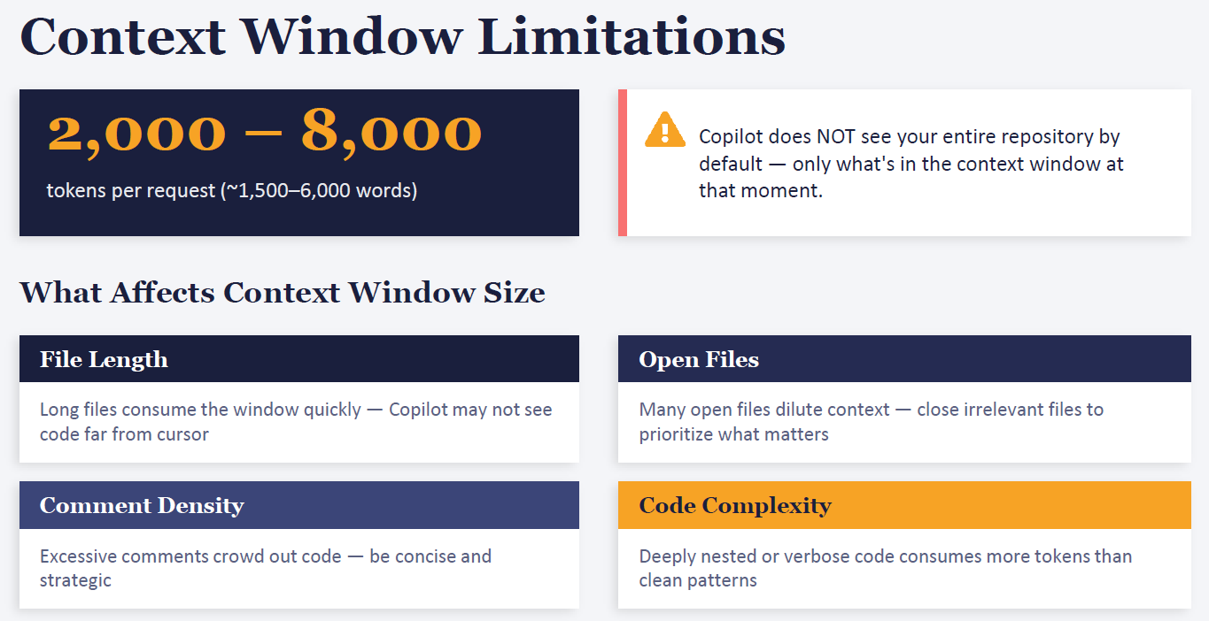
📏 Context Window Size
- Copilot’s context window is typically 2,000–8,000 tokens per request (~1,500–6,000 words).
- That means Copilot can only “see” a slice of your codebase at one time, not the entire repository.
- Think of it like a flashlight beam: it illuminates only part of the room (your code), not everything at once.

🔎 Factors That Affect Context
1. File Length
- Meaning: Long files quickly consume the window, so Copilot may not see code far from your cursor.
- .NET Example: If OrderService.cs is 2,000 lines long, and your cursor is near the bottom, Copilot won’t see the top methods (like ValidateOrder) unless you scroll up or open them.
2. Open Files
- Meaning: Many open files dilute context — Copilot spreads attention across them.
- .NET Example: If you open OrderController.cs, OrderService.cs, PaymentService.cs, and UserService.cs all at once, Copilot may only partially capture each. Closing irrelevant files helps it focus.
3. Comment Density
- Meaning: Excessive comments crowd out code in the window.
- .NET Example: If you write long explanatory comments in OrderConsumer.cs, Copilot may spend tokens on those instead of the actual Kafka consumer logic. Concise comments like // Retry on failure are more effective.
4. Code Complexity
- Meaning: Deeply nested or verbose code consumes more tokens than clean patterns.
- .NET Example: A method with multiple nested if statements and verbose logging eats more context space than a clean, modular method. Copilot may miss surrounding logic if the nesting is too heavy.
⚠️ Key Insight
👉 Copilot doesn’t see your whole repo. It only sees what fits in the context window at that moment.
- If files are too long, open tabs too many, or comments too verbose, Copilot’s “vision” shrinks.
- That’s why sometimes it gives perfect suggestions (when context is clear and concise) and other times generic ones (when context is diluted).
✅ Best Practices for You (.NET context)??
- Keep files modular (shorter classes/services).
- Open only relevant files when prompting Copilot.
- Use strategic comments (clear intent, not essays).
- Refactor nested logic into smaller methods to save context space.

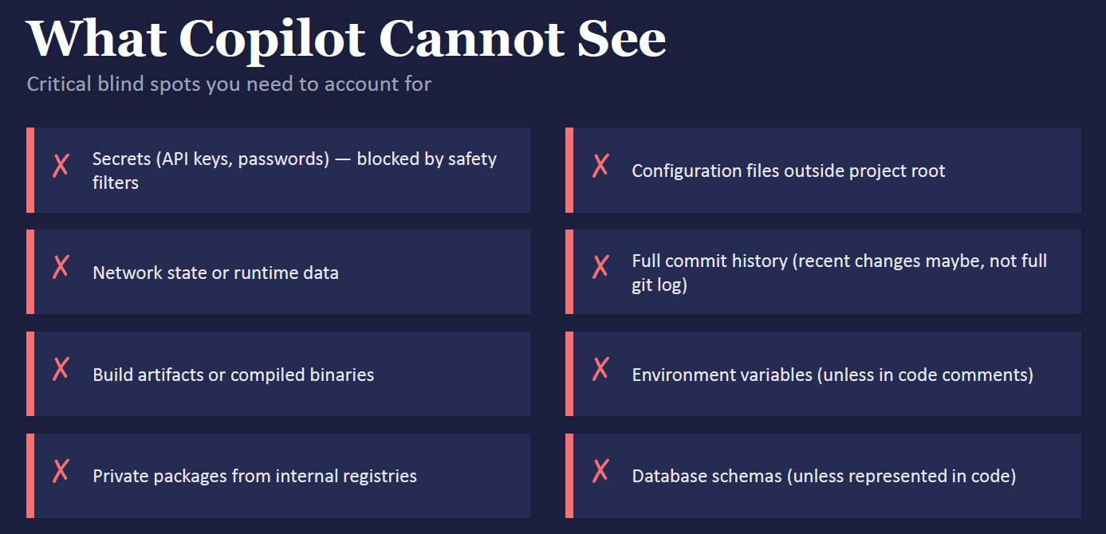
🚫 Things Copilot Cannot See
1. Secrets (API keys, passwords)
- Blocked by safety filters.
- .NET Example: If you store Jwt:Key = "supersecret123" in appsettings.json, Copilot won’t expose or use it directly.
- Implication: You must guide Copilot with placeholders like "Configuration["Jwt:Key"]" instead of expecting it to know your actual secret.
2. Network State or Runtime Data
- Copilot doesn’t know what’s happening at runtime.
- .NET Example: If your Kafka consumer is failing due to broker downtime, Copilot can’t “see” that. It can only suggest retry logic based on code context.
- Implication: Debugging runtime issues is still your job.
3. Build Artifacts or Compiled Binaries
- Copilot doesn’t read DLLs, EXEs, or compiled outputs.
- .NET Example: If you build your project and generate OrderService.dll, Copilot can’t inspect it.
- Implication: Copilot works only with source code, not compiled binaries.

4. Private Packages from Internal Registries
- Copilot doesn’t have access to your private NuGet feeds.
- .NET Example: If you use a custom NuGet package like Company.Messaging.Kafka, Copilot won’t know its internals unless you open the source code.
- Implication: You may need to paste or open relevant package code for Copilot to generate accurate suggestions.
5. Configuration Files Outside Project Root
- Copilot only sees files inside your project workspace.
- .NET Example: If you keep global.json or nuget.config outside the repo root, Copilot won’t read them.
- Implication: Keep critical configs inside the project or open them in the IDE.
6. Full Commit History
- Copilot doesn’t see your entire Git log. It may only infer recent changes.
- .NET Example: If you previously refactored OrderService in a commit, Copilot won’t know unless the file is open.
- Implication: Copilot won’t automatically align with past commit decisions.
7. Environment Variables
- Copilot doesn’t know your runtime environment variables unless you reference them in code.
- .NET Example: If you set ASPNETCORE_ENVIRONMENT=Production, Copilot won’t see it unless you use Environment.GetEnvironmentVariable("ASPNETCORE_ENVIRONMENT") in code.
- Implication: Explicitly reference env vars in code if you want Copilot to consider them.
8. Database Schemas
- Copilot doesn’t see your live database schema unless represented in code.
- .NET Example: If your SQL Server has a Orders table, Copilot won’t know unless you have EF Core models like Order.cs.
- Implication: Copilot generates queries based on models, not the actual database.

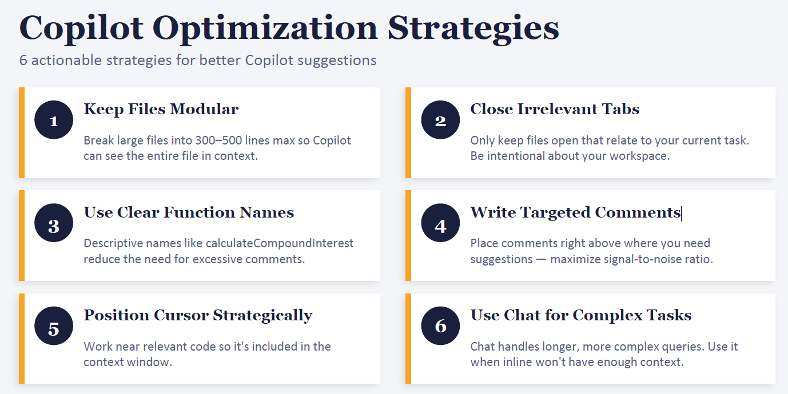
🔧 1. Keep Files Modular
- Idea: Break large files into smaller ones (300–500 lines).
- .NET Example: Instead of one giant OrderService.cs with all business logic, split into OrderValidationService.cs, OrderProcessingService.cs, and OrderRepository.cs.
- Benefit: Copilot can “see” the whole file and give precise suggestions.
📑 2. Close Irrelevant Tabs
- Idea: Only keep files open that relate to your current task.
- .NET Example: If you’re working on Kafka consumers, close unrelated files like UserService.cs.
- Benefit: Copilot focuses on the right context instead of diluting across many files.
📝 3. Use Clear Function Names
- Idea: Descriptive names reduce the need for excessive comments.
- .NET Example:
  - Bad: DoStuff()
  - Good: CalculateCompoundInterest() or RetryFailedOrders().
- Benefit: Copilot infers intent directly from the name.
💬 4. Write Targeted Comments
- Idea: Place comments right above where you need suggestions.
- .NET Example:
csharp
// Retry on failure with exponential backoff
public async Task Consume(ConsumeContext<OrderCreated> context) { ... }
- Benefit: Copilot uses comments as strong signals to generate relevant code.
🎯 5. Position Cursor Strategically
- Idea: Work near relevant code so it’s included in the context window.
- .NET Example: Place your cursor inside the Consume() method when asking for retry logic, not at the top of the file.
- Benefit: Copilot sees the surrounding method and generates context-aware suggestions.
💡 6. Use Chat for Complex Tasks
- Idea: Inline completions are short; chat handles longer, multi-file queries.
- .NET Example: Use Copilot Chat to ask: “Generate MassTransit Kafka consumer with retry, logging, and unit tests.”
- Benefit: Chat can process broader context and give structured answers.
✅ Key Takeaway
These strategies are about controlling Copilot’s context window. By keeping files modular, focusing tabs, naming clearly, writing strategic comments, placing your cursor wisely, and using chat for complex tasks, you maximize Copilot’s accuracy in your .NET microservices work.
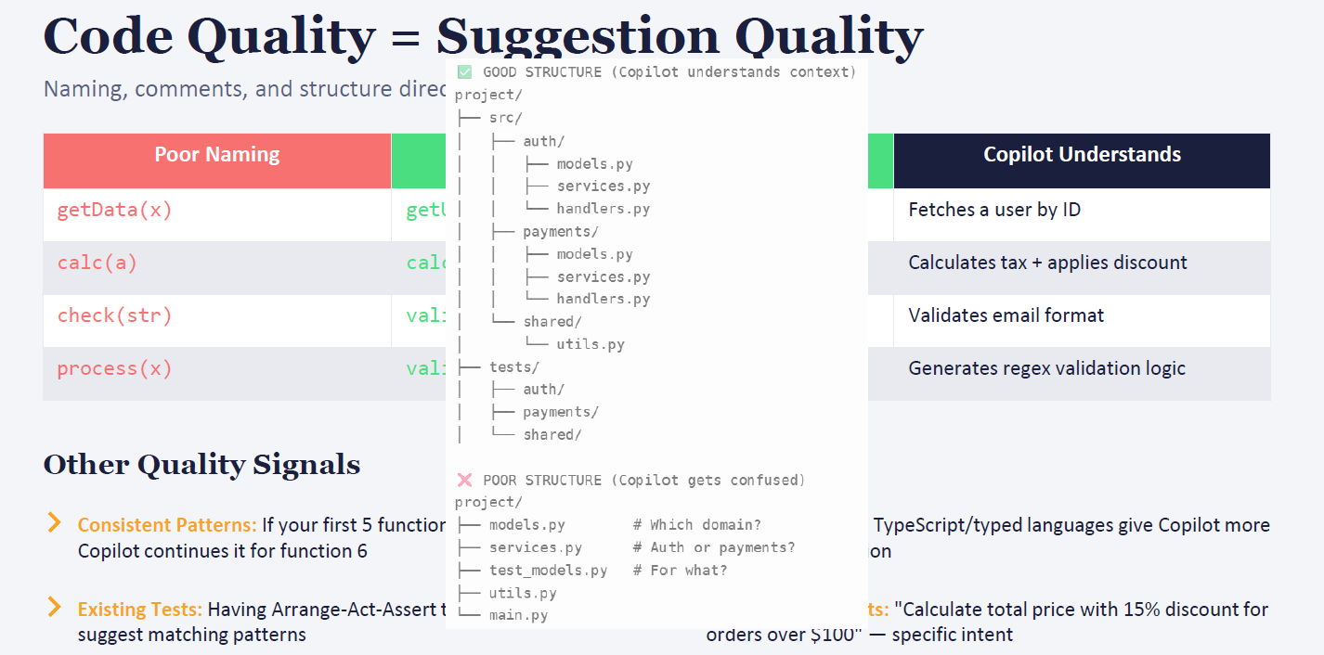

🔎 1. Naming Matters
- Poor Naming: getData(x), calc(a), check(str) → too vague.
- Better Naming: getUser(id), calcTax(price), validateEmail(email) → descriptive and specific.
- .NET Example:
  - Bad: Process()
  - Good: ProcessOrder(Order order)
- Impact: Copilot understands what the function is supposed to do and generates relevant logic.
📂 2. Project Structure
- Good Structure: Organized by domain (auth, payments, shared). Copilot can infer context.
- Poor Structure: Flat files (models.py, services.py) with no clear domain separation. Copilot gets confused.
- .NET Example:
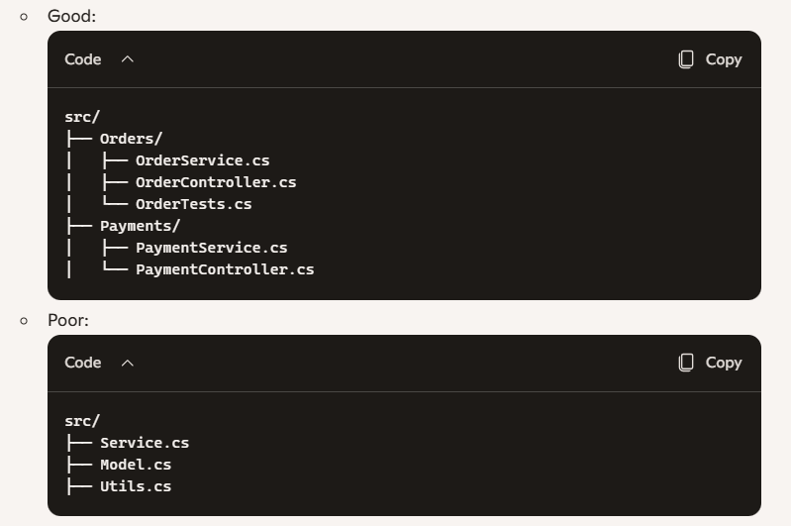
- Impact: With good structure, Copilot knows which code belongs to orders vs payments, so suggestions are domain-specific.
🧩 3. Copilot Infers Patterns
- If your first 5 functions follow a consistent pattern, Copilot continues it for function 6.
- .NET Example: If you write tests using Arrange-Act-Assert consistently, Copilot will generate new tests in the same format.
🧪 4. Existing Tests Help
- Having tests signals Copilot about expected behavior.
- .NET Example: If you already have OrderServiceTests with Arrange-Act-Assert, Copilot will generate similar tests for PaymentService.

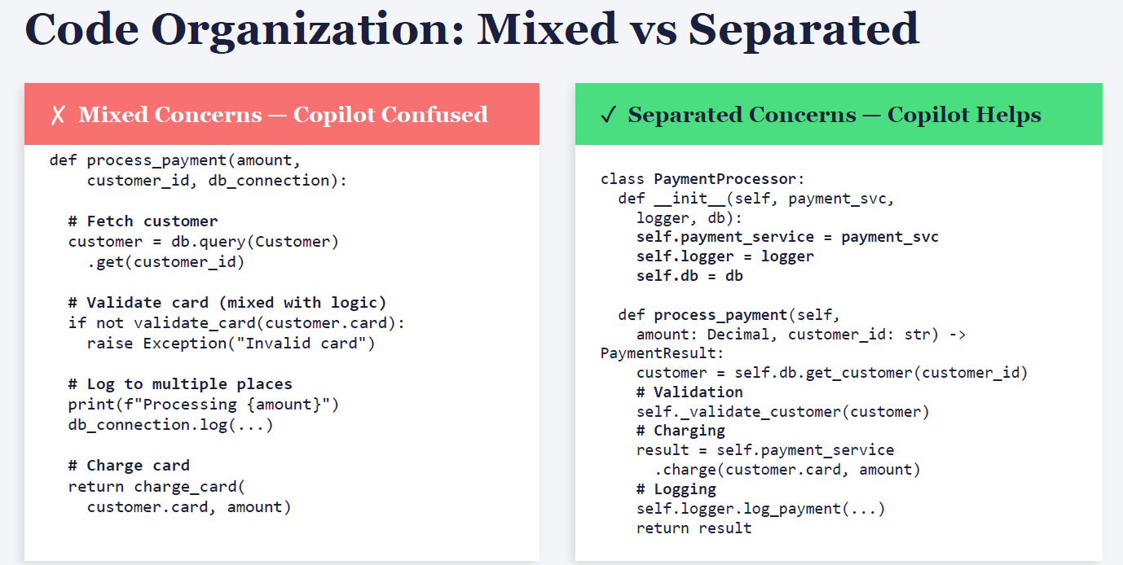
✗ Mixed Concerns — Copilot Confused
- What it means: One function tries to do too many things at once (fetching data, validating, logging, charging).
- Problem: Copilot sees a jumble of responsibilities and can’t infer clear intent.
- .NET Example:
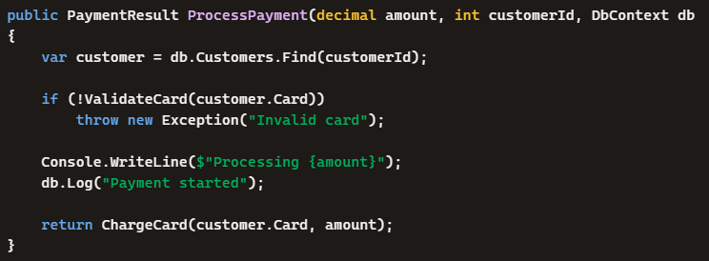
- → This mixes data access, validation, logging, and payment logic. Copilot may give vague or incorrect completions because it doesn’t know which responsibility to extend.
✓ Separated Concerns — Copilot Helps
- What it means: Responsibilities are split into smaller, focused methods or classes.
- Benefit: Copilot can infer intent from clear structure and generate precise code.
- .NET Example:
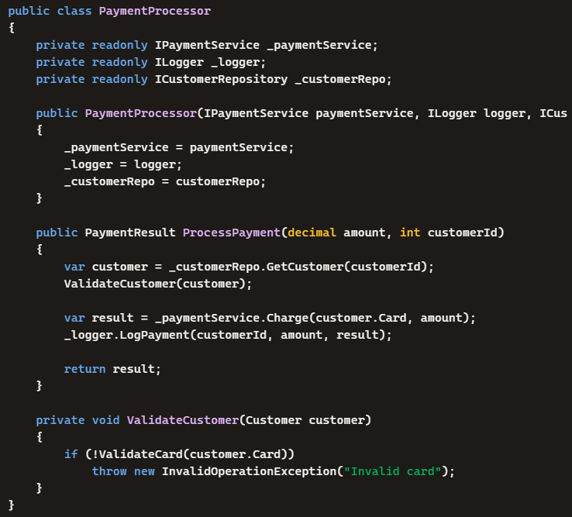
- → Each responsibility is separated: repository for data, validation method, payment service, logger. Copilot can now easily suggest improvements like retry logic, better logging, or unit tests.
✅ Key Takeaway
- Mixed concerns confuse Copilot → vague, generic suggestions.
- Separated concerns guide Copilot → accurate, domain-specific suggestions.
- This mirrors good software design principles (SOLID, separation of concerns) and makes Copilot a stronger coding partner.
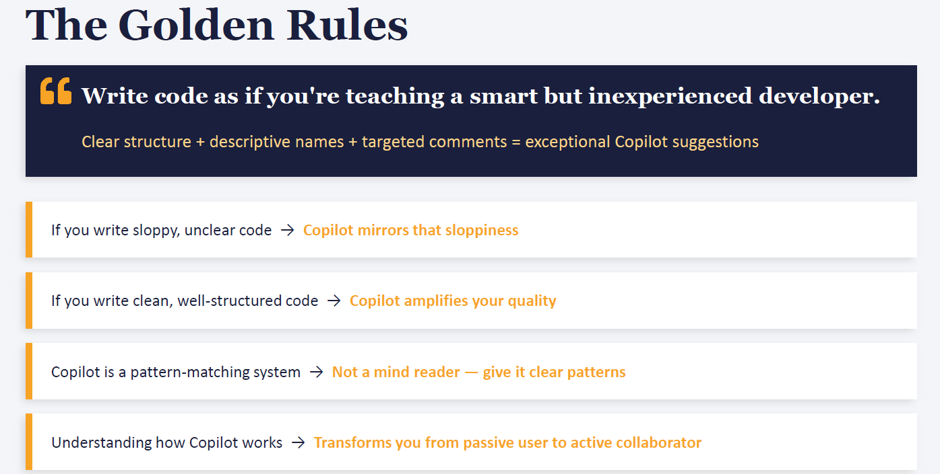
✨ The Golden Rules Explained
1. Write code as if teaching a smart but inexperienced developer
- Copilot is powerful, but it relies on patterns.
- If your code is clear, Copilot can follow along like a junior developer learning from you.
- .NET Example:
csharp
// Validates order before saving
public bool ValidateOrder(Order order) { ... }
→ Copilot understands the intent and can suggest validation logic.
2. Clear structure + descriptive names + targeted comments = exceptional suggestions
- Structure: Organize files by domain (Orders, Payments, Consumers).
- Names: Use descriptive function names (ProcessOrder, RetryFailedOrders).
- Comments: Place concise hints where you want help.
- Impact: Copilot mirrors your clarity with precise completions.
3. Sloppy code → sloppy suggestions
- If you write vague, unclear code, Copilot mirrors that vagueness.
- .NET Example:
  - Bad: DoStuff() → Copilot guesses randomly.
  - Good: CalculateTax(decimal price) → Copilot generates tax logic correctly.
4. Clean code → amplified quality
- Copilot doesn’t invent patterns; it extends the ones you give it.
- .NET Example: If your first 5 unit tests follow Arrange-Act-Assert, Copilot will generate the 6th test in the same format.
5. Copilot is a pattern-matching system, not a mind reader
- It doesn’t know your architecture unless you show it through naming, structure, and comments.
- .NET Example: If you comment // Retry on failure with exponential backoff, Copilot will generate retry logic. Without the comment, it may just add a generic try/catch.
6. Active collaborator mindset
- Understanding how Copilot works transforms you from a passive user into an active collaborator.
- You guide Copilot with clear signals, and it amplifies your intent.
- .NET Example: Instead of waiting for Copilot to guess, you nudge it with comments like:
csharp
// Consumer should log errors and retry 3 times

✅ Key Takeaway
Copilot reflects your coding discipline:
- Clear names → precise suggestions.
- Good structure → domain-aware completions.
- Targeted comments → context-specific logic.
- Consistency → Copilot continues your patterns.
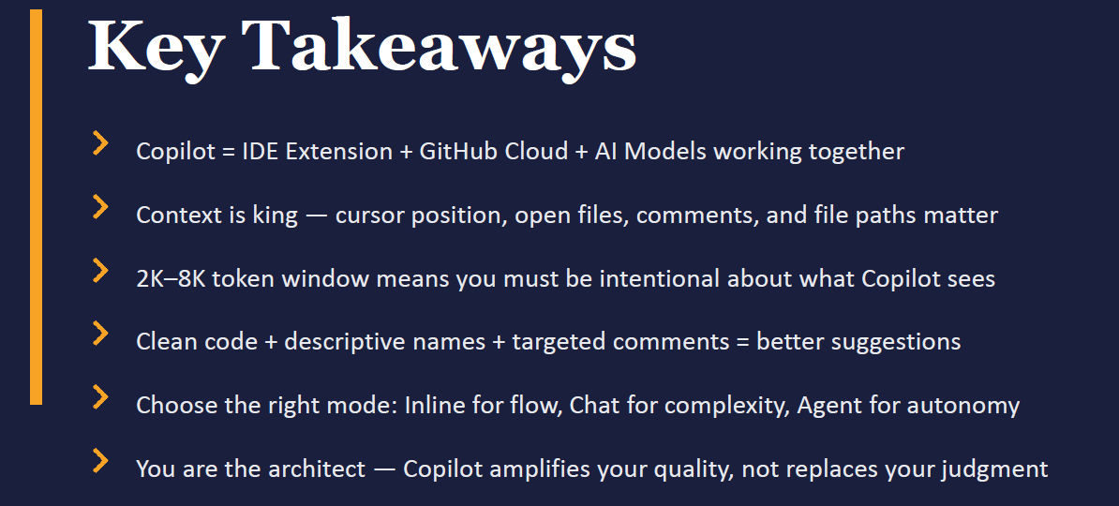

📌 Key Takeaways Explained
1. Copilot = IDE Extension + GitHub Cloud + AI Models
- It’s not just autocompleted. It’s your IDE plugin, GitHub’s proxy + safety layers, and large language models working together.
- .NET Example: When you type in Visual Studio, your request flows through GitHub Cloud, gets filtered, then reaches the AI model before suggestions appear.
2. Context is King
- Cursor position, open files, comments, and file paths define what Copilot “sees.”
- .NET Example: If your cursor is inside OrderConsumer.cs with a comment // Retry on failure, Copilot will generate retry logic. If you’re at the top of the file with no comments, suggestions will be generic.
3. Token Window (2K–8K tokens ≈ 1,500–6,000 words)
- Copilot doesn’t see your whole repo, only what fits in the window.
- .NET Example: In a 2,000-line OrderService.cs, Copilot may only see the section near your cursor. That’s why modular files help.
4. Clean Code = Better Suggestions
- Descriptive names, clear structure, and targeted comments amplify Copilot’s quality.
- .NET Example:
  - Bad: DoStuff() → vague suggestions.
  - Good: ValidateOrder(Order order) → Copilot generates validation logic correctly.
5. Choose the Right Mode
- Inline → quick flow completions.
- Chat → complex, multi-file queries.
- Agent → autonomous tasks (like refactoring across services).
- .NET Example: Use inline for a LINQ query, chat for Kafka consumer scaffolding, agent for repo-wide refactor.
6. You Are the Architect
- Copilot amplifies your quality; it doesn’t replace your judgment.
- .NET Example: Copilot may suggest retry logic, but you decide if it should be exponential backoff, circuit breaker, or a custom policy.
✅ Big Picture
Copilot is like a junior developer shadowing you:
- If you give it clear signals (names, comments, structure), it produces strong code.
- If you’re sloppy, it mirrors that sloppiness.
- You remain the architect — Copilot is your accelerator, not your replacement.

let’s break this down step by step so you fully understand context windows, tokens, caching, and cost calculation.

📏 Context Window
- The context window is the maximum “memory span” the AI can see at once.
- Typical size: 2,000–8,000 tokens (~1,500–6,000 words).
- Think of it like a whiteboard: only what fits on the board is visible to Copilot.
- .NET Example: If OrderService.cs is 2,000 lines long, Copilot only sees ~20 lines around your cursor plus open tabs, comments, and repo hints — not the entire file.
🔡 Tokens
- A token is a chunk of text (≈ 4 characters in English).
- Words are broken into tokens:
  - "Kafka" → 2 tokens (Ka, fka)
  - "OrderConsumer" → 3 tokens (Order, Cons, umer)
- Why it matters: Both your input and Copilot’s output consume tokens.
📝 Input Tokens
- These are tokens from your prompt + context.
- Includes: cursor code, comments, open files, repo structure.
- .NET Example:
→ This comment + surrounding code is converted into input tokens.
🖊️ Output Tokens
- These are tokens generated by the AI as suggestions.
- .NET Example: Copilot outputs:
csharp

→ Each word is broken into tokens, counted toward the output.
⚡ Cache
- Copilot caches common requests to save cost and speed up responses.
- .NET Example: Thousands of devs ask Copilot to scaffold JWT middleware. The proxy caches that snippet so it doesn’t recompute every time.
- Benefit: Faster suggestions, lower compute cost.
🔄 Previous Prompts (Context Carryover)
- Copilot can take input from previous prompts if they’re still inside the context window.
- .NET Example:
  - Prompt 1: // Add retry logic
  - Prompt 2: // Also add logging → If both fit in the window, Copilot combines them: retry + logging.
💰 Cost Calculation
- Cost is based on total tokens processed (input + output).
- Formula (simplified):
$$\text{Cost}=(\text{Input Tokens}+\text{Output Tokens})×\text{Rate per Token}$$
- Example:
  - Input = 1,000 tokens (~750 words of code/comments).
  - Output = 500 tokens (~350 words of suggestion).
  - Total = 1,500 tokens.
  - If rate = $0.00001 per token → Cost = $0.015.
- Caching reduces cost because repeated prompts don’t always hit the model.
✅ Key Takeaway
- Context window = how much Copilot can “see” at once.
- Tokens = building blocks of text.
- Input tokens = your code + comments.
- Output tokens = Copilot’s suggestions.
- Cache = saves repeated work.
- Cost = proportional to total tokens processed.
Module 3: Context
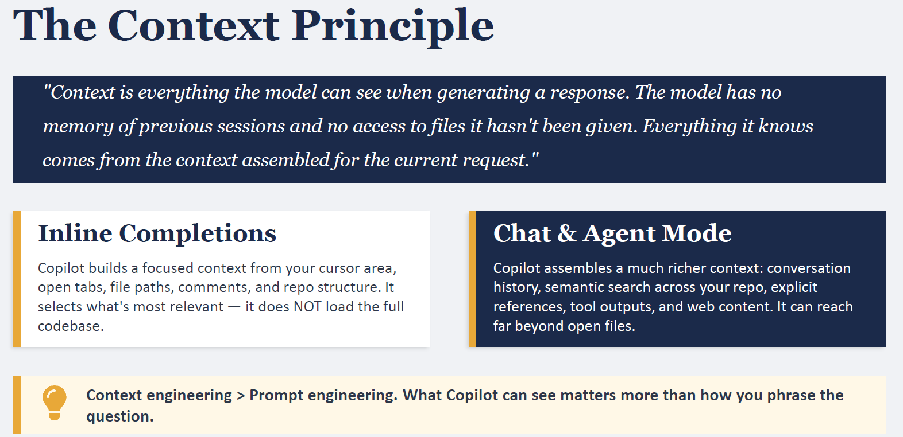
🔎 What Context Really Means
- Definition: Context is everything the model can see at the moment of generating a response.
- Copilot has no memory of past sessions and no access to files you haven’t opened or referenced.
- It builds a temporary “snapshot” of your coding environment each time you trigger a suggestion.
👉 Think of it like a camera lens: it only captures what’s in frame (cursor area, open files, comments, repo hints). Anything outside the frame is invisible.
✍️ Inline Completions
- How it works: Copilot builds a focused context from:
  - Cursor area (~20 lines above/below)
  - Open tabs
  - File paths & language
  - Comments & docstrings
  - Repo structure (file names, directories)
- .NET Example:
  - Cursor inside OrderConsumer.cs with comment // Retry on failure.
  - Copilot sees that local code + comment and generates retry logic.
  - It does not load your entire repo or database schema.
💬 Chat & Agent Mode
- How it works: Copilot assembles a richer context:
  - Conversation history
  - Semantic search across your repo
  - Explicit references (files you mention)
  - Tool outputs (like test results)
  - Web content (if allowed)
- .NET Example:
  - You ask in chat: “Generate MassTransit Kafka consumer with retry and logging, based on OrderConsumer.cs and PaymentConsumer.cs.”
  - Copilot pulls both files, your comments, and repo structure into context.
  - It can then generate a more complete solution across multiple files.
⚠️ Key Insight
- Context engineering > prompt engineering
- What Copilot can see matters more than how you phrase the question.
- If you want better suggestions:
  - Open the right files.
  - Place your cursor strategically.
  - Add targeted comments.
  - Use chat for multi-file or complex tasks.
✅ Summary for You (.NET context)
- Inline = local scope (cursor + open files).
- Chat/Agent = broader scope (repo search + conversation history).
- Copilot doesn’t remember past sessions — only what’s in the current snapshot.
- Your job as architect: engineer the context so Copilot sees the right signals.
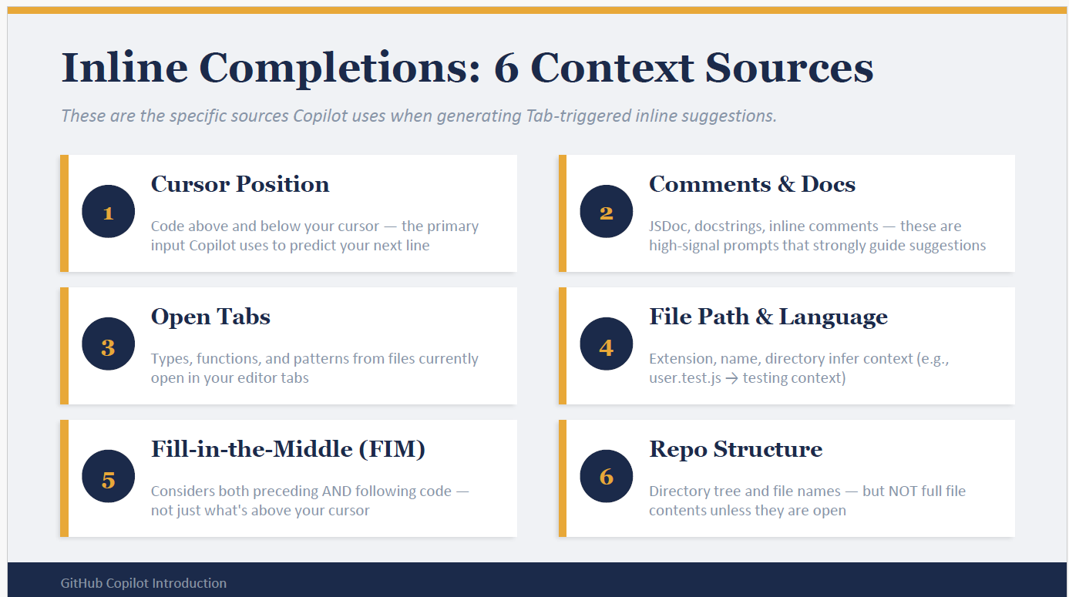
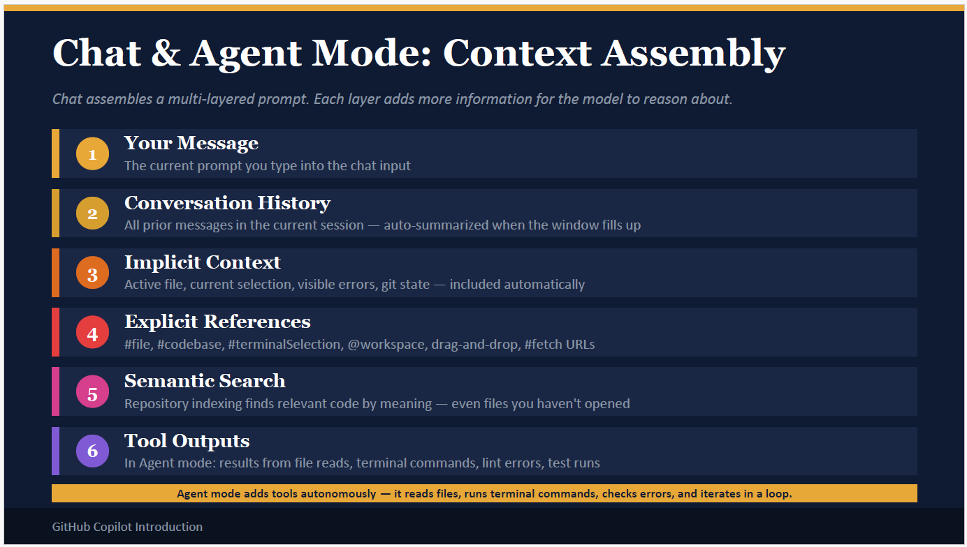

🧩 Layers of Context
1. Your Message
- The text you type in chat.
- .NET Example: “Generate a MassTransit Kafka consumer with retry and logging.”
- This is the starting point.
2. Conversation History
- All prior messages in the current chat session.
- Auto-summarized when the window fills up.
- .NET Example: If earlier you asked about JWT middleware, Copilot remembers that and may suggest integrating JWT with your Kafka consumer.
3. Implicit Context
- Automatically included signals: active file, current selection, visible errors, git state.
- .NET Example: If your IDE shows a compilation error in OrderConsumer.cs, Copilot knows and can suggest a fix.
4. Explicit References
- Files or code you explicitly mention or attach.
- .NET Example: You say “Use #OrderConsumer.cs and #PaymentConsumer.cs” → Copilot pulls those files into context.
5. Semantic Search??
- Copilot indexes your repo and finds relevant code by meaning, even if you haven’t opened the file.
- .NET Example: You ask about “retry logic in consumers” → Copilot finds RetryPolicy.cs in your repo automatically.
6. Tool Outputs (Agent Mode only)
- In agent mode, Copilot can autonomously:
  - Read files
  - Run terminal commands
  - Check lint/test errors
  - Iterate in a loop until the task is complete
- .NET Example: You ask “Fix failing Kafka consumer tests”. Agent mode might:
  - Run your test suite
  - Read the error logs
  - Patch the consumer code
  - Re-run tests until they pass.
⚠️ Key Insight
- Inline completions = narrow context (cursor + open files).
- Chat mode = broader context (conversation + repo search + references).
- Agent mode = autonomous context (tools + iteration).
- 👉 The richer the context, the smarter the suggestions.
✅ Summary for You (.NET context)
- Chat mode lets you guide Copilot with conversation + references.
- Agent mode lets Copilot act like a junior developer running commands/tests.
- Your role: engineer the context (open files, add comments, reference code) so Copilot has the right signals.

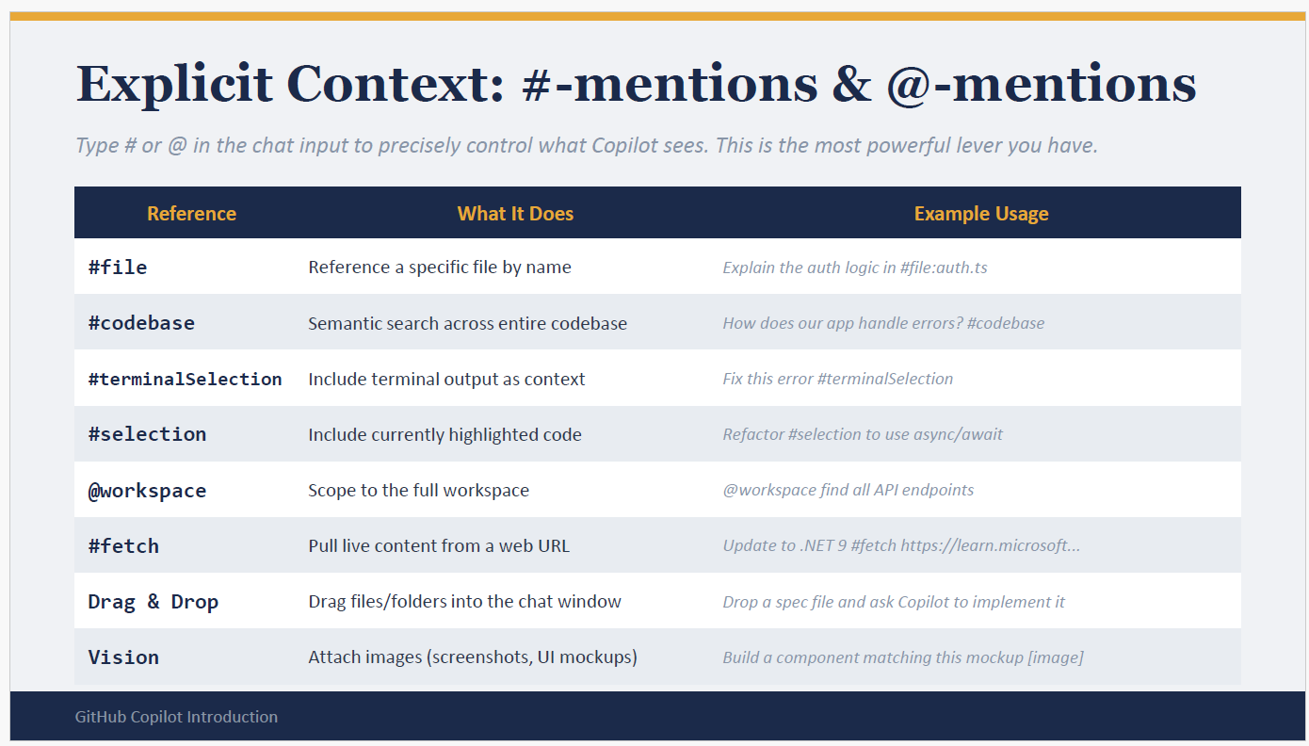
🧩 Explicit Context References
1. #file
- Pulls a specific file into context.
- Example: Explain the auth logic in #file:auth.ts
- .NET Example: Explain the retry logic in #file:OrderConsumer.cs

2. #codebase
- What it does: Runs semantic search across your entire repo, even unopened files.
- Use case: Repo-wide queries by meaning, not just file names.
- Examples:
  - How does our app handle errors? #codebase → Copilot finds error-handling patterns across services.
  - Where do we configure Kafka brokers? #codebase → Copilot locates broker settings in config files.

Example 3: Error Handling
Prompt:
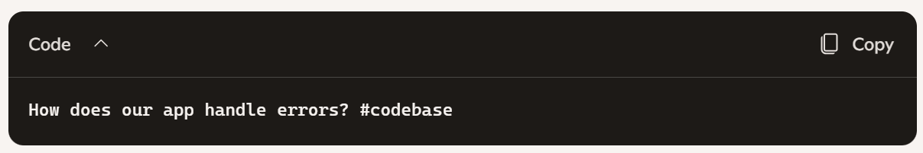
What happens:
- Copilot searches across your repo for error-handling logic.
- It might pull in GlobalExceptionMiddleware.cs, RetryPolicy.cs, and LoggerConfig.cs.
- You’ll get a consolidated explanation of how exceptions are caught, logged, and retried.

3. #terminalSelection
🖥️ What is #terminalSelection?
- It’s a way to include terminal output (errors, logs, build/test results) directly into Copilot Chat.
- Instead of pasting raw logs and hoping Copilot interprets them, you tag them with #terminalSelection.
- Copilot then treats that output as explicit context for its reasoning.
🔧 How It Works
- You run a command in your terminal (e.g., dotnet build or dotnet test).
- You select the error or output text.
- In Copilot Chat, you reference it with #terminalSelection.
- Copilot uses that error log to suggest fixes or explanations.
📂 Examples
Example 1: Build Error
Prompt:
Code

Terminal Output Selected:
Code

Copilot Response:
- Explains that a semicolon is missing.
- Points to the exact line in your code.
- Suggests the corrected snippet.
Example 2: Test Failure
Prompt:
Code

Terminal Output Selected:
Code
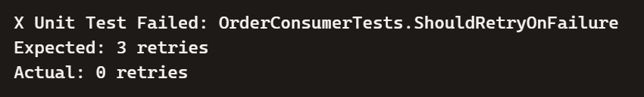 Copilot Response:
- Identifies that retry logic isn’t being applied.
- Suggests updating RetryPolicy.cs or consumer configuration.
- Provides corrected code with exponential backoff.
Example 3: Runtime Exception
Prompt:
Code
Terminal Output Selected:
Code
Copilot Response:
- Explains what a NullReferenceException means.
- Suggests adding null checks in PaymentConsumer.cs.
- Provides a safe handling snippet.
Example 4: CI/CD Pipeline Error
Prompt:
Code
Terminal Output Selected:
Code
Copilot Response:
- Explains that the NuGet package is missing or misconfigured.
- Suggests adding the correct version to csproj or updating nuget.config.
- Provides the exact command to restore.
✅ Key Takeaway
- #terminalSelection = debugging assistant.
- Instead of generic guesses, Copilot uses your actual error logs.
- Perfect for build errors, test failures, runtime exceptions, and CI/CD issues.

4. #selection
- Uses the currently highlighted code in your editor.
- Example: Refactor #selection to use async/await
- .NET Example: Highlight a LINQ query and ask Copilot to optimize it.
5. @workspace
- What it does: Scopes Copilot’s reasoning to the entire workspace (all files in your repo).
- Use case: Broad queries across your project.
- Examples:
- @workspace list all Kafka consumers → Copilot scans your repo for consumer classes.
- @workspace find all API endpoints → Copilot identifies controllers and routes in your .NET solution.
- Benefit: Great for architecture-level questions.
Example 1: Kafka Consumer Setup
@workspace → tells Copilot to look across your entire repo.
#fetch → pulls in live external docs or specs.

What happens:
- Copilot scans your repo for existing consumers (OrderConsumer.cs, PaymentConsumer.cs).
- It also reads the MassTransit Kafka Rider docs.
- Response: Code for InventoryConsumer aligned with your repo’s patterns + correct Rider setup

6. #fetch
- What it does: Pulls live content from a web URL into context.
- Use case: When you want Copilot to use external documentation or specs.
- Examples:
  - Add MassTransit Kafka Rider setup #fetch https://masstransit-project.com/... → Copilot reads official docs and applies them to your code.
  - Update to .NET 9 #fetch https://learn.microsoft.com/... → Copilot uses Microsoft docs to guide migration.
- Benefit: Ensures Copilot bases suggestions on authoritative sources.

7. Drag & Drop
- You can drag files/folders into chat.
- Example: Drop a spec file and ask Copilot to implement it.
- .NET Example: Drop OrderConsumerTests.cs and ask Copilot to generate missing tests.
8. Vision
- Attach images (screenshots, UI mockups).
- Example: Build a component matching this mockup [image]
- .NET Example: Upload a diagram of your microservice architecture and ask Copilot to scaffold services.

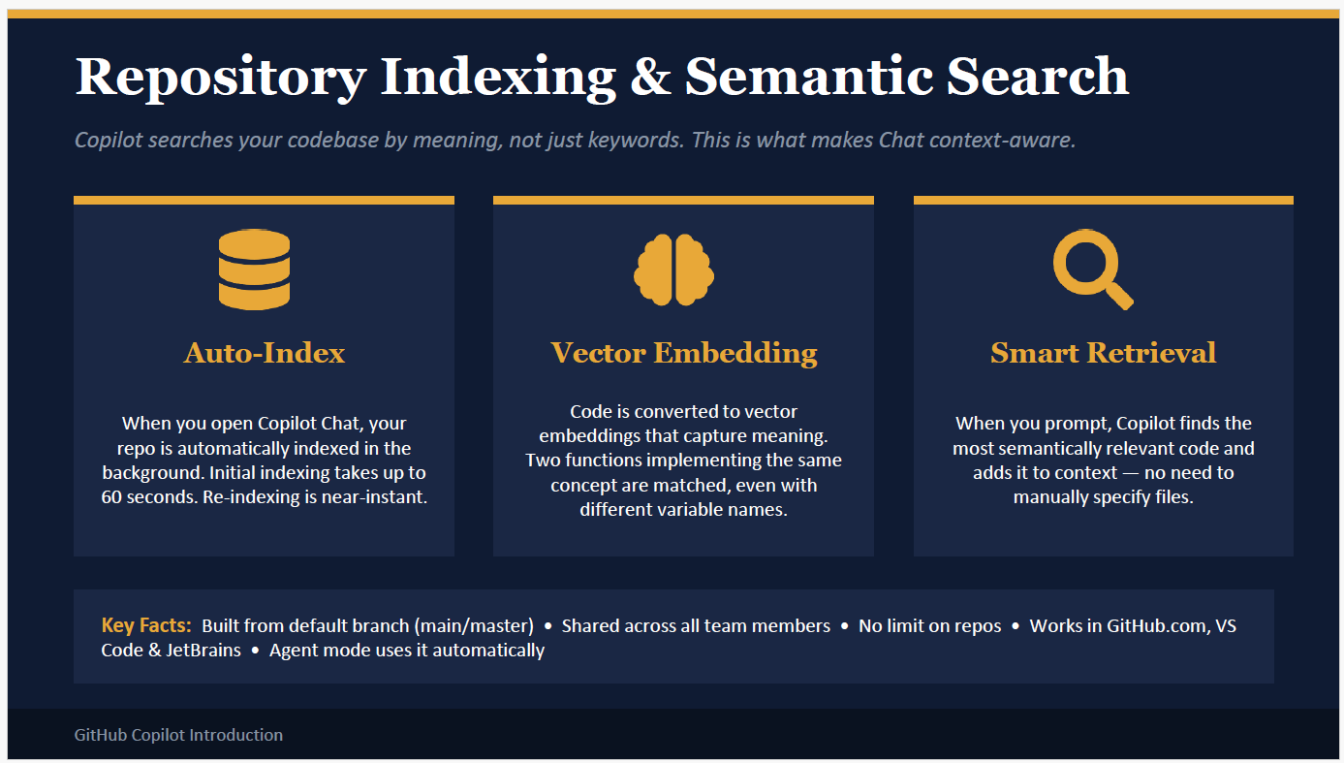
🗂️ 1. Auto-Index
- What it is: When you open Copilot Chat, your repository is automatically scanned and indexed in the background.
- How it works:
  - Copilot looks at the default branch (usually main or master).
  - It parses all files — source code, configs, tests — and builds a searchable map.
  - The first indexing takes ~60 seconds, but after that, re-indexing is near-instant (because only changed files are updated).
- Why it matters:
  - You don’t need to manually tell Copilot where things are.
  - Once indexed, you can ask repo-wide questions like “Where are all Kafka consumers defined?” and Copilot can answer immediately.
- .NET Example:
  - Repo has OrderConsumer.cs, PaymentConsumer.cs, RetryPolicy.cs.
  - Auto-indexing maps these files so Copilot can later retrieve them when you ask about “consumers” or “retry logic.”

🧠 2. Vector Embedding??
- What it is: Code is converted into vector embeddings — mathematical representations that capture meaning, not just keywords.
- How it works:
  - Each function, class, or file is transformed into a vector (a list of numbers).
  - Similar concepts produce vectors that are “close” to each other in this space.
  - Copilot can then match code by meaning, even if names differ.
- Why it matters:
  - Copilot doesn’t just keyword search; it understands semantic similarity.
  - Functions with different names but similar logic are linked.
- .NET Example:
  - File A: ValidateOrder(Order order)
  - File B: CheckOrder(Order o) → Both are embedded as “order validation” logic. Copilot knows they’re related, even though the names differ.
  - If you ask “How do we validate orders?”, Copilot retrieves both.

🔍 3. Smart Retrieval
- When you prompt Copilot, it retrieves the most semantically relevant code and adds it to context.
- You don’t need to manually specify files unless you want to.
- .NET Example: You ask “How do we handle retries?” → Copilot finds RetryPolicy.cs and OrderConsumer.cs automatically, even if you didn’t open them.
📌 Key Facts
- Indexing is built from the default branch (main/master).
- Shared across all team members (so everyone benefits).
- No repo limit — works across GitHub.com, VS Code, JetBrains.
- Agent mode uses it automatically (so when Copilot acts autonomously, it leverages semantic search).
✅ Why This Matters
- Inline completions only see local context (cursor + open files).
- Chat/Agent mode uses semantic search to pull in relevant code across the repo.
- This is why #codebase queries are so powerful — Copilot isn’t just keyword searching, it’s meaning-searching.
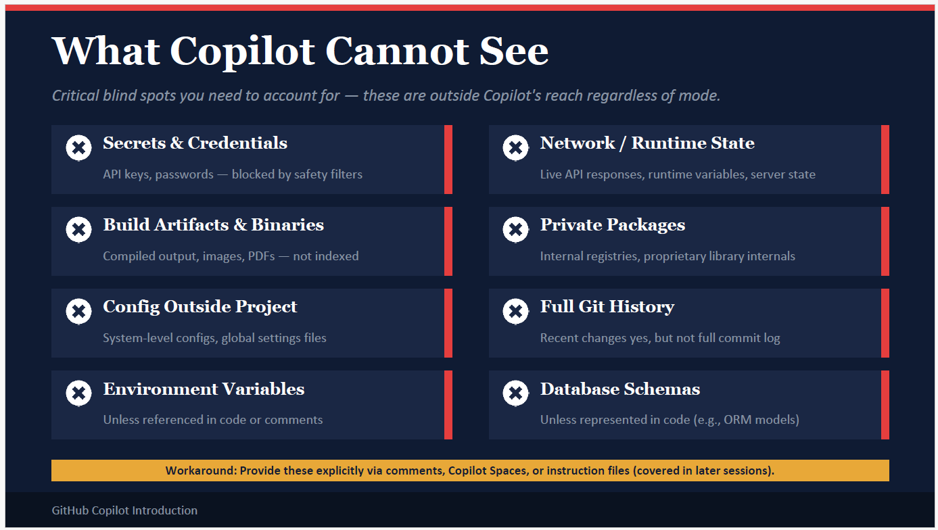
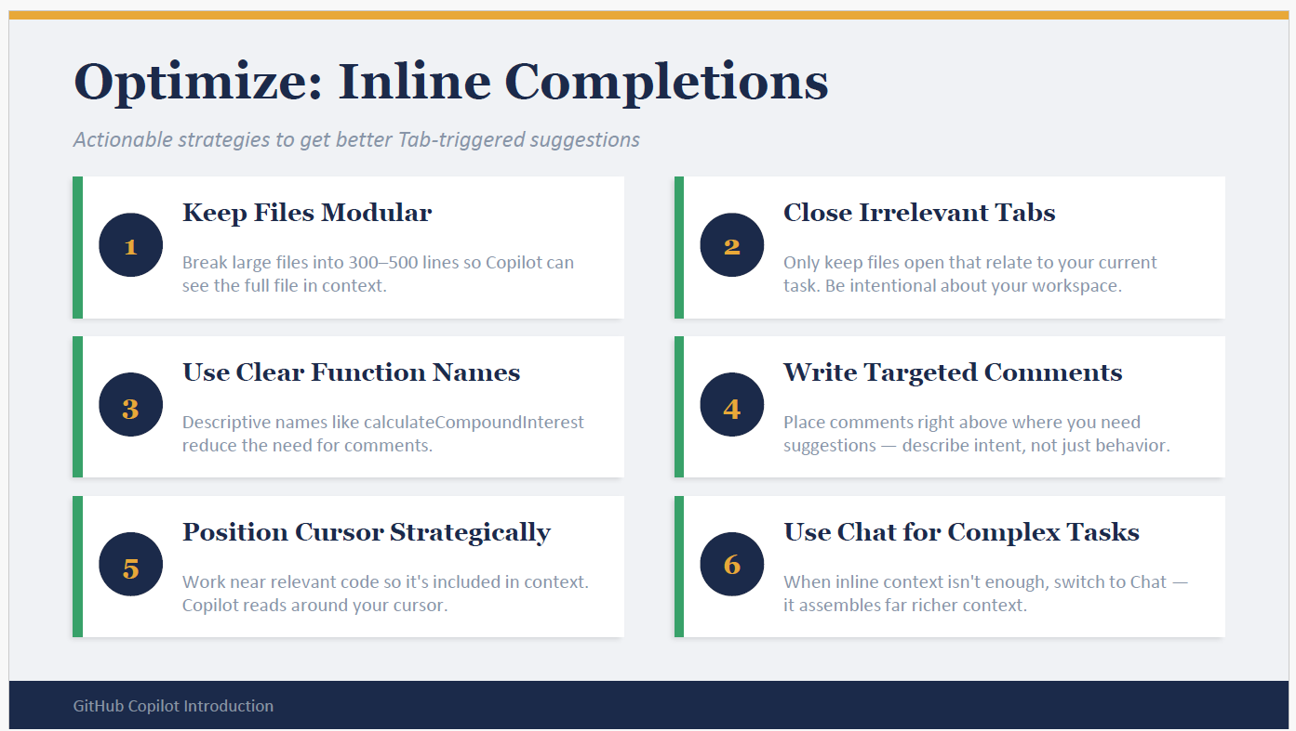

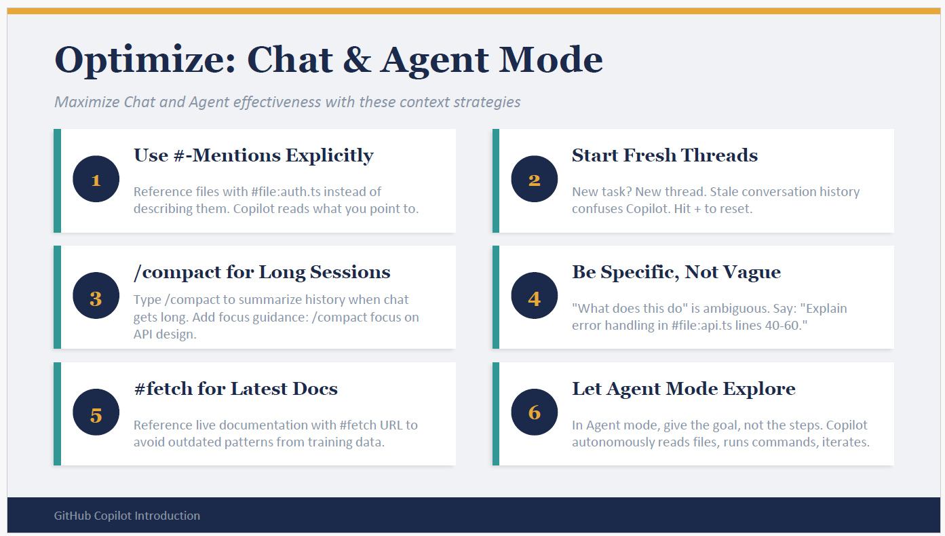
🧩 1. Use #-Mentions Explicitly
- Instead of describing files vaguely, reference them directly.
- Example: Explain the auth logic in #file:auth.ts
- .NET Example: Explain retry logic in #file:OrderConsumer.cs
- Benefit: Copilot reads exactly what you point to, no guessing.
🔄 2. Start Fresh Threads
- Each new task should start in a new chat thread.
- Old conversation history can confuse Copilot.
- Example: If you switch from Kafka consumers to JWT middleware, hit “+” to reset.
- Benefit: Keeps context clean and focused.
📦 3. /compact for Long Sessions
- Use /compact to summarize history when chat gets too long.
- You can add focus guidance: /compact focus on API design.
- Benefit: Prevents Copilot from being distracted by stale prompts.
🎯 4. Be Specific, Not Vague
- Ambiguous prompts confuse Copilot.
- Bad: “What does this do?”
- Good: “Explain error handling in #file:api.ts lines 40–60.”
- .NET Example: “Explain retry logic in #file:OrderConsumer.cs lines 20–50.”
- Benefit: Copilot gives precise, context-aware answers.
🌐 5. #fetch for Latest Docs
- Use #fetch to bring in live documentation.
- Example: Update to .NET 9 #fetch https://learn.microsoft.com/...
- Benefit: Avoids outdated patterns from training data, ensures suggestions match current standards.
🤖 6. Let Agent Mode Explore
- In agent mode, give the goal, not the steps.
- Copilot autonomously reads files, runs commands, checks errors, iterates.
- Example: “Fix failing Kafka consumer tests.”
- Copilot will: run tests → read errors → patch code → retry until fixed.
- Benefit: You delegate the process, Copilot handles the iteration.

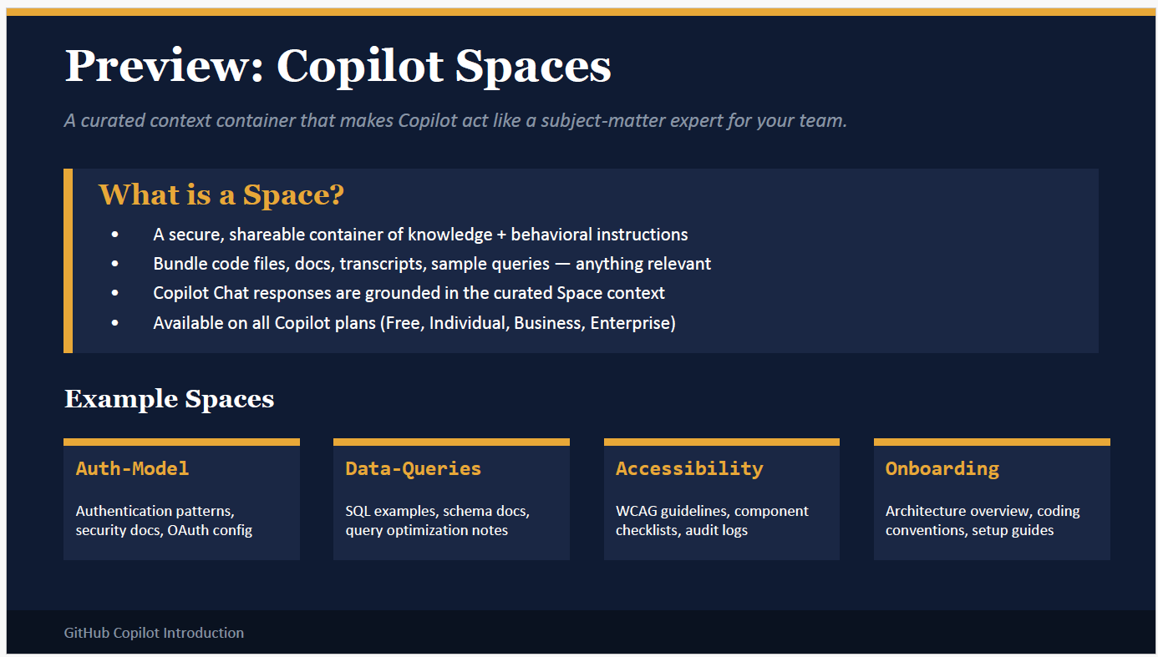

🌌 What is a Copilot Space?
A Space is like a curated context container. Instead of Copilot only seeing your cursor or open files, you can bundle together all the relevant knowledge for a specific domain or project.
Think of it as creating a mini knowledge vault that Copilot uses to act like a subject-matter expert.
🧩 What Goes into a Space
You can include:
- Code files (e.g., OrderConsumer.cs, RetryPolicy.cs)
- Docs (e.g., architecture overview, setup guides)
- Transcripts (e.g., meeting notes, design discussions)
- Sample queries (e.g., “How do we validate orders?”)
- Behavioral instructions (e.g., “Always follow WCAG accessibility guidelines”)
Copilot Chat responses are then grounded in this curated context, not just the repo snapshot.

📂 Example Spaces
1. Auth-Model
- Contents: Authentication patterns, OAuth config, security docs.
- Usage: Ask Copilot “Generate JWT middleware based on Auth-Model Space”.
- Benefit: Copilot knows your team’s security conventions, not just generic auth code.
2. Data-Queries
- Contents: SQL examples, schema docs, query optimization notes.
- Usage: “Optimize this query using Data-Queries Space.”
- Benefit: Copilot suggests optimizations aligned with your schema and best practices.
3. Accessibility
- Contents: WCAG guidelines, component checklists, audit logs.
- Usage: “Review this UI component for accessibility issues.”
- Benefit: Copilot applies accessibility rules consistently.
4. Onboarding
- Contents: Architecture overview, coding conventions, setup guides.
- Usage: “Explain our microservice architecture to a new developer.”
- Benefit: Copilot acts like a mentor, teaching from curated onboarding docs.
✅ Why Spaces Matter
- Team alignment: Everyone shares the same curated context.
- Consistency: Copilot amplifies your team’s standards, not random patterns.
- Flexibility: You can create multiple Spaces for different domains (auth, payments, onboarding).
- Security: Spaces are secure and shareable only within your team.
🔧 Practical .NET Example for You
Imagine you create a Kafka-Microservices Space:
- Bundle:
  - OrderConsumer.cs, PaymentConsumer.cs
  - Retry policy docs
  - MassTransit Rider setup guide
  - CI/CD pipeline notes
- Then ask Copilot: “Generate a new InventoryConsumer aligned with Kafka-Microservices Space.”
- Copilot will:
  - Follow your retry conventions.
  - Use MassTransit Rider setup correctly.
  - Apply logging patterns from your docs.
  - Suggest tests in your Arrange-Act-Assert style.
✅ Key Takeaway
- Spaces = curated context containers.
- They make Copilot act like a domain expert by grounding it in your team’s files, docs, and rules.
- Perfect for large projects, onboarding, or enforcing standards across a team.
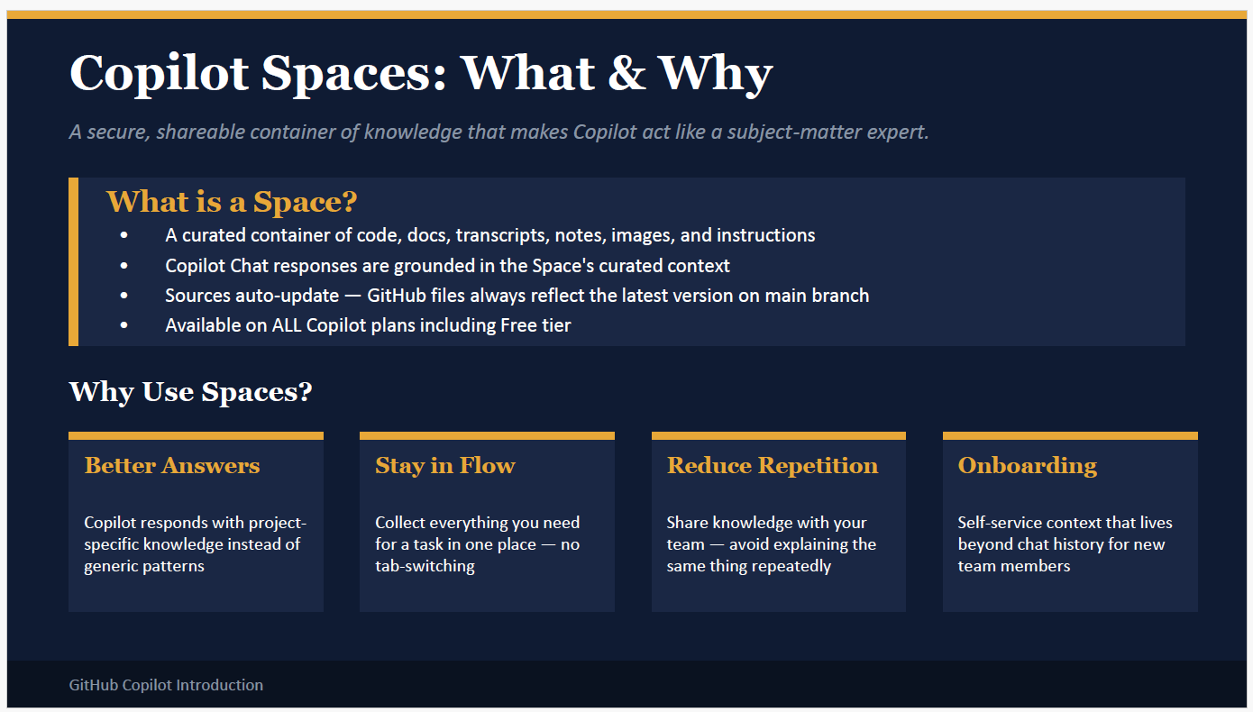
🌌 What is a Copilot Space?
A Space is a secure, shareable container of knowledge that you curate.
- It can include code files, documentation, transcripts, notes, images, and instructions.
- Copilot Chat responses are then grounded in this curated context, instead of relying only on cursor position or open files.
- Sources auto-update: if your GitHub repo changes on the main branch, the Space reflects the latest version.
- Available across all Copilot plans (even free tier).
👉 Think of a Space as a project-specific knowledge vault that makes Copilot behave like a subject-matter expert for that domain.
🎯 Why Use Spaces?
1. Better Answers
- Copilot responds with project-specific knowledge instead of generic patterns.
- Example: In a Kafka-Microservices Space, Copilot knows your retry conventions and logging style, so when you ask “Generate a new consumer”, it follows your team’s standards.
2. Stay in Flow
- Collect everything you need for a task in one place — no tab switching.
- Example: In a Data-Queries Space, you include schema docs + SQL examples. Copilot can optimize queries without you hunting through multiple files.
3. Reduce Repetition
- Share knowledge with your team.
- Example: Instead of explaining OAuth setup to every new developer, you put it in an Auth-Model Space. Copilot then answers onboarding questions consistently.
4. Onboarding
- Spaces live beyond chat history.
- Example: An Onboarding Space contains architecture overview, coding conventions, setup guides. A new developer asks Copilot: “Explain our microservice architecture” → Copilot teaches from curated docs.
🔧 Practical .NET Example for You
Imagine you create a Kafka-Microservices Space:
- Contents:
  - OrderConsumer.cs, PaymentConsumer.cs
  - Retry policy documentation
  - MassTransit Rider setup guide
  - CI/CD pipeline notes
- Usage:
  - Ask: “Generate InventoryConsumer aligned with Kafka-Microservices Space.”
- Copilot will:
  - Follow your retry conventions.
  - Use MassTransit Rider setup correctly.
  - Apply logging patterns from your docs.
  - Suggest Arrange-Act-Assert style tests.
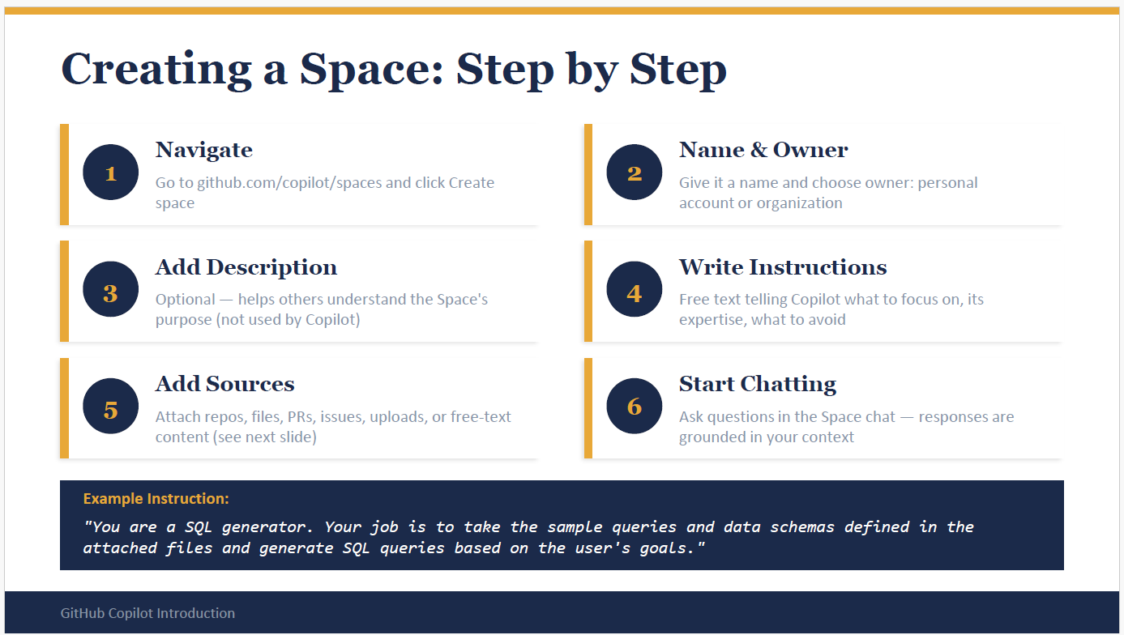
🪜 Step 1: Navigate
- Action: Go to github.com/copilot/spaces and click Create Space.
- Example: You decide to create a Kafka-Microservices Space for your event-driven architecture project.
🪜 Step 2: Name & Owner
- Action: Give the Space a name and choose whether it belongs to your personal account or your organization.
- Example:
  - Name: Kafka-Microservices
  - Owner: Your team’s GitHub org (so everyone can use it).
🪜 Step 3: Add Description
- Action: Write an optional description to help others understand the Space’s purpose.
- Note: This description is for humans, not Copilot.
- Example: “This Space contains our Kafka consumer patterns, retry policies, and CI/CD setup notes for microservices.”
🪜 Step 4: Write Instructions
- Action: Provide free-text instructions telling Copilot what to focus on, what expertise to apply, and what to avoid.
- Example: “You are a microservices architect. Always generate Kafka consumers using MassTransit Rider. Apply retry logic with exponential backoff. Avoid generic logging — use Serilog with structured logs.”
👉 This is where you “teach” Copilot your team’s rules.
🪜 Step 5: Add Sources
- Action: Attach the actual knowledge Copilot should use.
- Sources can be: repos, files, PRs, issues, uploads, or free-text content.
- Example:
  - Attach OrderConsumer.cs, PaymentConsumer.cs
  - Upload retry policy documentation
  - Add CI/CD pipeline notes
  - Include your architecture diagram
🪜 Step 6: Start Chatting
- Action: Begin asking questions in the Space chat. Copilot’s answers are grounded in the curated context.
- Example:
  - You ask: “Generate a new InventoryConsumer aligned with Kafka-Microservices Space.”
  - Copilot responds with code that:
    - Uses MassTransit Rider setup
    - Applies your retry conventions
    - Logs with Serilog
    - Suggests Arrange-Act-Assert style tests
✅ Key Takeaway
- A Space is like a curated knowledge vault.
- You define the rules, sources, and focus.
- Copilot then acts like a subject-matter expert for that domain.
- Perfect for team consistency, onboarding, and complex projects.
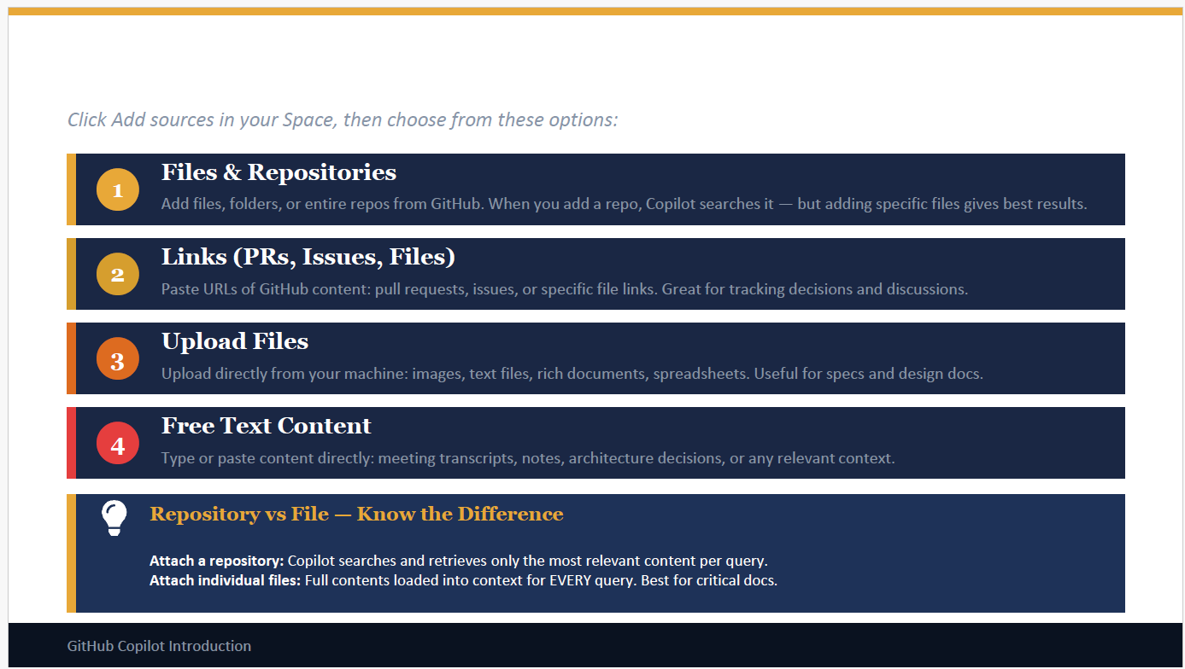
🪜 1. Files & Repositories
- What it does: You can attach entire repos or specific files from GitHub.
- Difference:
  - Repo → Copilot searches it and retrieves only the most relevant pieces per query.
  - File → The full contents are loaded into context for every query.
- Example:
  - Attach OrderConsumer.cs → Copilot always sees the full consumer code.
  - Attach your repo → Copilot searches across all services but only pulls what’s relevant.
- Best practice: Use files for critical docs (retry policy, logging conventions), repos for broader exploration.
🪜 2. Links (PRs, Issues, Files)
- What it does: Paste URLs of GitHub content like pull requests, issues, or specific file links.
- Example:
  - Add a PR link: “Refactor retry logic in Kafka consumers.”
  - Add an issue link: “Bug: PaymentConsumer fails on null card.”
- Benefit: Copilot can reference team discussions and decisions, not just code.
🪜 3. Upload Files
- What it does: Upload directly from your machine — images, text files, docs, spreadsheets.
- Example:
  - Upload a PDF spec for your CI/CD pipeline.
  - Upload a diagram of your microservice architecture.
- Benefit: Copilot can use design docs and specs that aren’t in GitHub.
🪜 4. Free Text Content
- What it does: Type or paste content directly into the Space.
- Example:
  - Paste meeting notes: “Retry logic must use exponential backoff with max 5 attempts.”
  - Paste architecture decisions: “All consumers must log errors with Serilog structured logging.”
- Benefit: Quick way to add context without uploading files.
📌 Repository vs File — Know the Difference
- Attach a repository → Copilot searches it and retrieves only the most relevant snippets.
- Attach individual files → Copilot loads the entire file into context for every query.
- Best practice:
  - Use files for critical rules (retry policies, logging standards).
  - Use repos for general exploration (all consumers, all services).
✅ Practical Example for You
Imagine you’re building a Kafka-Microservices Space:
- Files: OrderConsumer.cs, RetryPolicy.cs, LoggingConventions.md
- Repo: Your full microservices repo
- Links: PR for “Refactor retry logic” + Issue for “PaymentConsumer bug”
- Uploads: Architecture diagram (PNG), CI/CD pipeline spec (PDF)
- Free Text: Meeting notes on retry + logging rules
Now, when you ask Copilot: “Generate a new InventoryConsumer aligned with Kafka-Microservices Space.” → Copilot will:
- Apply retry logic from RetryPolicy.cs
- Follow logging rules from LoggingConventions.md
- Reference architecture diagram for service boundaries
- Respect decisions from PRs/issues
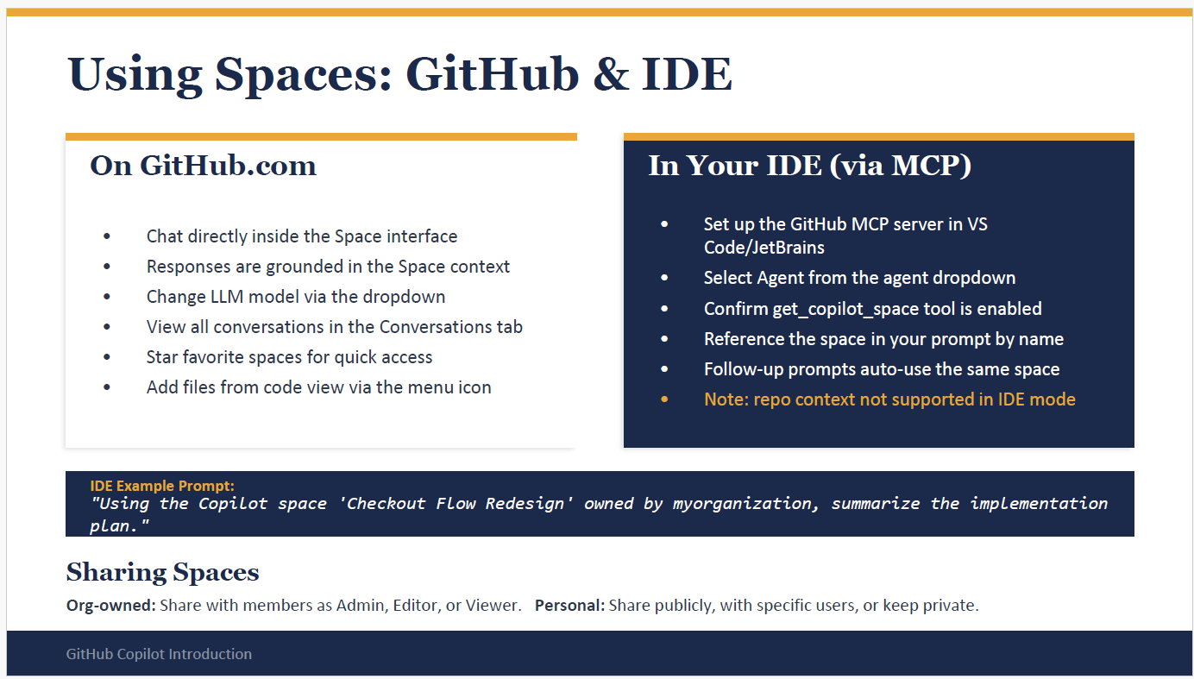
🖥️ Using Spaces on GitHub.com
- Chat directly inside the Space interface → You ask questions, and Copilot’s responses are grounded in the curated Space context. Example: In your Kafka-Microservices Space, you ask: “Generate a new consumer aligned with our retry policy.” Copilot uses the attached files and docs to give project-specific code.
- Change LLM model via dropdown → You can switch between different AI models depending on your needs (e.g., faster vs more thorough).
- View all conversations in the Conversations tab → Keeps a history of chats inside that Space. Example: You can revisit earlier discussions about CI/CD setup without losing context.
- Star favorite Spaces for quick access → Pin your most used Spaces (e.g., Auth-Model, Kafka-Microservices) so they’re easy to find.
- Add files from code view via menu icon → While browsing a repo, you can add files directly into a Space. Example: You’re reviewing PaymentConsumer.cs and decide to add it to your Kafka Space with one click.
🛠️ Using Spaces in Your IDE (via MCP)
- Set up GitHub MCP server in VS Code or JetBrains → This connects your IDE to Copilot Spaces.
- Select Agent from the agent dropdown → Choose the Copilot agent that will use the Space context.
- Confirm get_copilot_space tool is enabled → Ensures your IDE can reference Spaces.
- Reference the Space in your prompt by name → You explicitly tell Copilot which Space to use. Example Prompt: “Using the Copilot space ‘Checkout Flow Redesign’ owned by myorganization, summarize the implementation plan.”
- Follow-up prompts auto-use the same Space → Once you reference a Space, subsequent prompts stay grounded in it until you switch.
- ⚠️ Note: Repo context is not supported in IDE mode. You must explicitly reference Spaces.
👥 Sharing Spaces
- Org-owned Spaces: Share with members as Admin, Editor, or Viewer. Example: Your team’s Kafka-Microservices Space is shared with developers (Editors) and architects (Admins).
- Personal Spaces: Share publicly, with specific users, or keep private. Example: You create a personal Learning Space with notes on MassTransit and share it only with a mentor.
✅ Key Takeaway
- On GitHub.com, Spaces are interactive hubs where you chat, add files, and manage context.
- In IDE mode, you reference Spaces by name to ground Copilot’s responses in curated knowledge.
- Sharing makes Spaces collaborative, ensuring team members get consistent, project-specific answers.
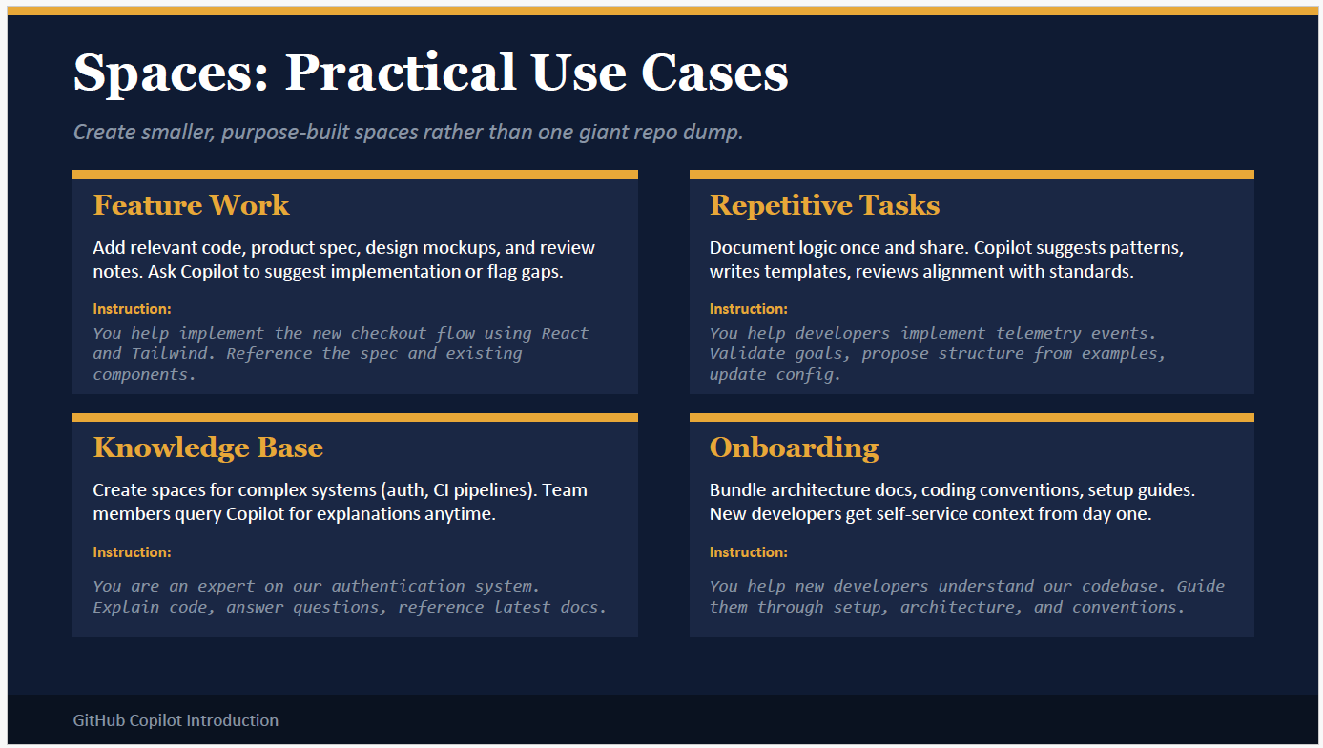
🛠️ 1. Feature Work
- What it is: A Space built around a specific feature you’re developing.
- Contents: Relevant code files, product specs, design mockups, review notes.
- Scenario: You’re building a new checkout flow.
  - Add: CheckoutController.cs, React components, Tailwind design mockups, product spec doc.
  - Instruction: “You help implement the new checkout flow using React and Tailwind. Reference the spec and existing components.”
- Benefit: Copilot suggests implementation aligned with your design and flags gaps (e.g., missing validation).
🔁 2. Repetitive Tasks
- What it is: A Space for tasks that repeat across projects.
- Contents: Documented logic, templates, examples, config files.
- Scenario: You want consistent telemetry events across services.
  - Add: Example telemetry events, config files, logging standards.
  - Instruction: “You help developers implement telemetry events. Validate goals, propose structure from examples, update config.”
- Benefit: Copilot generates telemetry code consistently, reviews alignment with standards, and saves you from repeating explanations.
📚 3. Knowledge Base
- What it is: A Space for complex systems where team members often have questions.
- Contents: Architecture docs, CI/CD pipeline notes, authentication guides.
- Scenario: Your team struggles with authentication system details.
  - Add: OAuth config, security docs, code files for auth middleware.
  - Instruction: “You are an expert on our authentication system. Explain code, answer questions, reference latest docs.”
- Benefit: Copilot becomes a self-service expert — developers can query it anytime without asking senior engineers.
👩‍💻 4. Onboarding
- What it is: A Space designed for new developers joining the team.
- Contents: Architecture overview, coding conventions, setup guides, starter tasks.
- Scenario: A new developer joins your Kafka microservices project.
  - Add: Architecture diagram, coding conventions doc, setup guide for MassTransit Rider, sample consumer code.
  - Instruction: “You help new developers understand our codebase. Guide them through setup, architecture, and conventions.”
- Benefit: Copilot acts like a mentor, walking new hires through setup and conventions without you repeating the same onboarding steps.
✅ Key Takeaway
- Feature Work Spaces → Focused on building one feature.
- Repetitive Task Spaces → Standardize recurring patterns.
- Knowledge Base Spaces → Act as subject-matter experts for complex systems.
- Onboarding Spaces → Help new developers ramp up quickly.
👉 Smaller, purpose-built Spaces = sharper, more relevant Copilot answers.
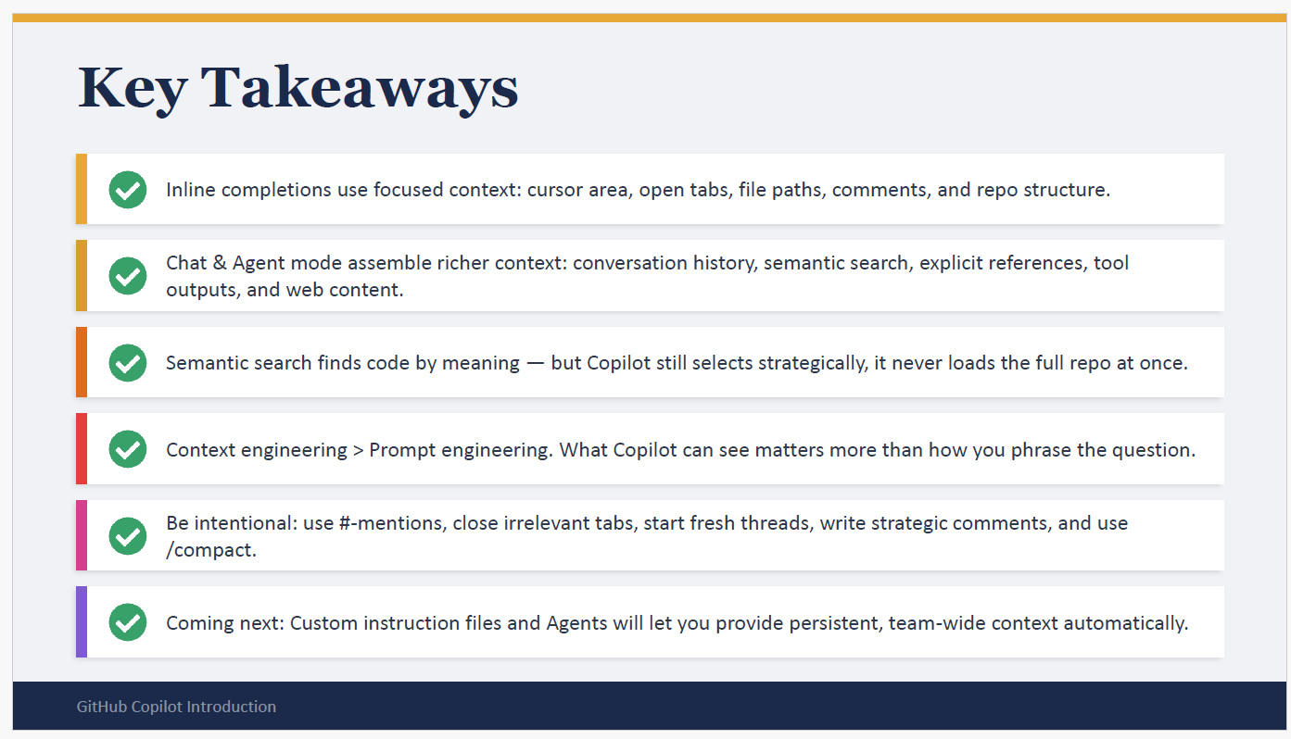
✅ Inline Completions = Focused Context
- Copilot looks only at your cursor area, open tabs, file paths, comments, and repo structure.
- Example: You type // Add retry logic above a Kafka consumer method. Copilot sees that comment + surrounding code and suggests retry logic. It does not scan your whole repo.
✅ Chat & Agent Mode = Richer Context
- Copilot assembles conversation history, semantic search, explicit references (#file, #codebase), tool outputs, and even web content.
- Example: In chat you ask: “Generate a new InventoryConsumer using #file:OrderConsumer.cs and MassTransit docs #fetch …” → Copilot pulls in your file, repo search results, and external docs.
✅ Semantic Search = Meaning, Not Keywords
- Copilot indexes your repo and finds code by meaning, not just names.
- Example: You ask “Where do we validate orders?” → Copilot retrieves both ValidateOrder(Order order) and CheckOrder(Order o) because embeddings capture their semantic similarity.
✅ Context Engineering > Prompt Engineering
- What Copilot can see matters more than how you phrase the question.
- Example: Instead of asking vaguely “Explain this”, you open the right file, add a comment, or reference with #file. That engineered context makes Copilot’s answer precise.
✅ Be Intentional
- Use context tools wisely:
  - #-mentions (e.g., #file:OrderConsumer.cs)
  - Close irrelevant tabs (so Copilot doesn’t get distracted)
  - Start fresh threads for new tasks
  - Write strategic comments
  - Use /compact to summarize long sessions
- Example: You’re switching from Kafka consumers to JWT middleware → start a new thread so Copilot doesn’t mix contexts.
✅ Coming Next: Custom Instructions & Agents
- Soon you’ll be able to provide persistent, team-wide context automatically.
- Example: A custom instruction file could tell Copilot: “Always use Serilog for logging, MassTransit Rider for Kafka, and retry with exponential backoff.” → Copilot applies these rules across all chats.
🔧 Practical Scenario for You
Imagine you’re debugging a failing Kafka consumer:
- Inline mode → Copilot sees your cursor + comment // Fix retry logic and suggests a snippet.
- Chat mode → You ask: “Fix retry logic in #file:OrderConsumer.cs using #fetch MassTransit docs.” Copilot combines repo + docs.
- Agent mode → You say: “Fix failing Kafka consumer tests.” Copilot runs tests, reads errors, patches code, retries until fixed.
